

**Scope Document for**

**HalloDoc Platform**

TatvaSoft House, Rajpath Club Road, Near Shivalik Business Center, Opp.

Golf Academy, Off S G Road, Ahmedabad - 380054, Gujarat, **India**

**PROPRIETARY AND CONFIDENTIAL**

This document is proprietary material of TATVASOFT prepared for its prospective client. By having access to this document, you agree to maintain strict confidentiality regarding its content. Disclosure of the same to any person/agency whom TATVASOFT would deem to be its.

competitor, would be considered a violation of confidentiality.

**Scope Document**

**Contents**

**1. Introduction...................................................................................................................**

# Platform page..................................................................................................................................

## Forgot Password..................................................................................................................................

**2. Admin Dashboard.........................................................................................................**

Admin dashboard in New state................................................................................................................

Admin dashboard in Pending state..........................................................................................................

Admin dashboard in Active state.............................................................................................................

Admin dashboard in Conclude state........................................................................................................

Admin dashboard in To Close state.........................................................................................................

Admin dashboard in Unpaid state...........................................................................................................

View case.......................................................................................................................................

View Notes....................................................................................................................................

Cancel Case....................................................................................................................................

Assign case.....................................................................................................................................

Block Case......................................................................................................................................

View Upload..................................................................................................................................

Orders...........................................................................................................................................

Transfer.........................................................................................................................................

Clear Case......................................................................................................................................

Send Agreement............................................................................................................................

Close Case .....................................................................................................................................

My Profile.......................................................................................................................................

Regions ..........................................................................................................................................

Request Support............................................................................................................................

Access/Roles...............................................................................................................................................

Account Access..............................................................................................................................

User Access.................................................................................................................................

Providers.....................................................................................................................................................

Scheduling...................................................................................................................................................

Day Wise Scheduling......................................................................................................................

Week Wise Scheduling...................................................................................................................

Month Wise Scheduling.................................................................................................................

Provider On call(MDs On Calls)….......................................................................................................

Requested Shifts.............................................................................................................................

Create Shift.....................................................................................................................................

View Edit/Delete Shift....................................................................................................................

Provider Location.......................................................................................................................................

Partners/Vendors.......................................................................................................................................

Add Business..................................................................................................................................

Patient Record................................................................................................................................

Search Record.................................................................................................................................

Logs(Email Logs/SMS Logs).............................................................................................................

Cancel History................................................................................................................................

Block History...................................................................................................................................

Create Requests..............................................................................................................................

**3.Provider dashboard......................................................................................................**

Provider Active State: Action >Encounter ................................................................................................

Provider Conclude State: Action > Encounter form .................................................................................

Provider > Pending State > Action > transfer request pop-up.................................................................. Provider My Profile....................................................................................................................................

**4.Patient site.......................................................................................................................**

Submit request c...............................................................................................................................

Create Patient request.............................................................................................................................

Create Family/friend request....................................................................................................................

Create concierge request .........................................................................................................................

Create business request............................................................................................................................

Registered Patient....................................................................................................................................

Reset Password..........................................................................................................................................

Patient Dashboard......................................................................................................................................

Create New Request...................................................................................................................................

Submit Information me..............................................................................................................................

Submit Information Someone else............................................................................................................

View Documents.........................................................................................................................................

# **1. Introduction**

The platform will offer online Doctors consultation and Diagnostics services. The HalloDoc platform, also known as a health-care website, serves as a valuable tool for doctors to enhance patient care and streamline their work processes. It offers a user-friendly interface that simplifies various tasks for doctors. They can conveniently access patient records, efficiently manage appointments, and securely communicate with their Patients. Additionally, patients can utilize the website to request care for themselves or on behalf of others. The platform accommodates three types of users: Admin, Physician, and Patients. The admin user has comprehensive access to patient and physician records, enabling them to review patient history, manage cases, and exercise control over requests by canceling or blocking them when necessary.

# Platform login page

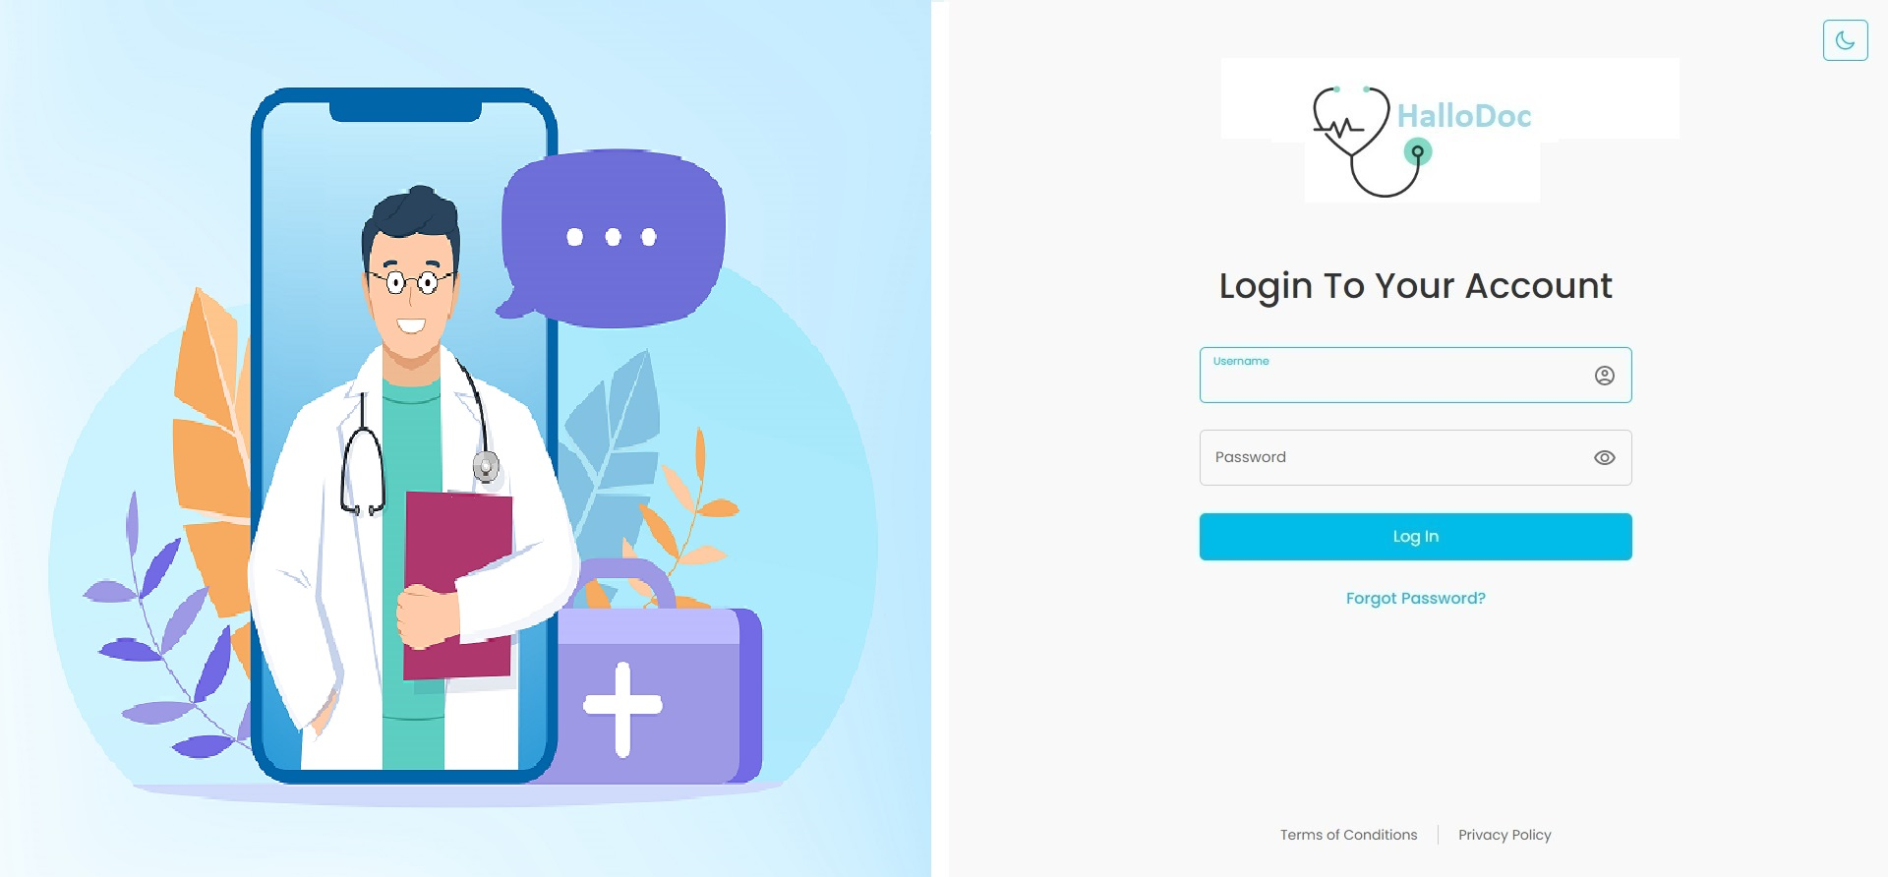**GC Description:**

This page will appear when the user lands on the platform. This page will have a banner on the left side and login section on the right side.

# Fig1. Platform login page

**Description:**

Users can login to the platform using their email address and password.

**Features:**

|  |  |  |  |
| --- | --- | --- | --- |
| **#** | **Feature** | **Type** | **Description** |
|  | Email address | Input | User will need to enter his email address in this text box. |
|  | Password | Input | Users will need to enter his password in this text box. |
|  | Login | Button | After entering the correct email address and password, clicking on this button will allow the user to sign into the platform. |
|  | Forgot password | Link | If a user forgets his or her password, he or she must select “Forgot password?” |
|  | Footer links | Link | It will display links to pages such as Terms of condition and privacy policy. |

|  |  |
| --- | --- |
|  |  |
|  |  |

## Forgot Password

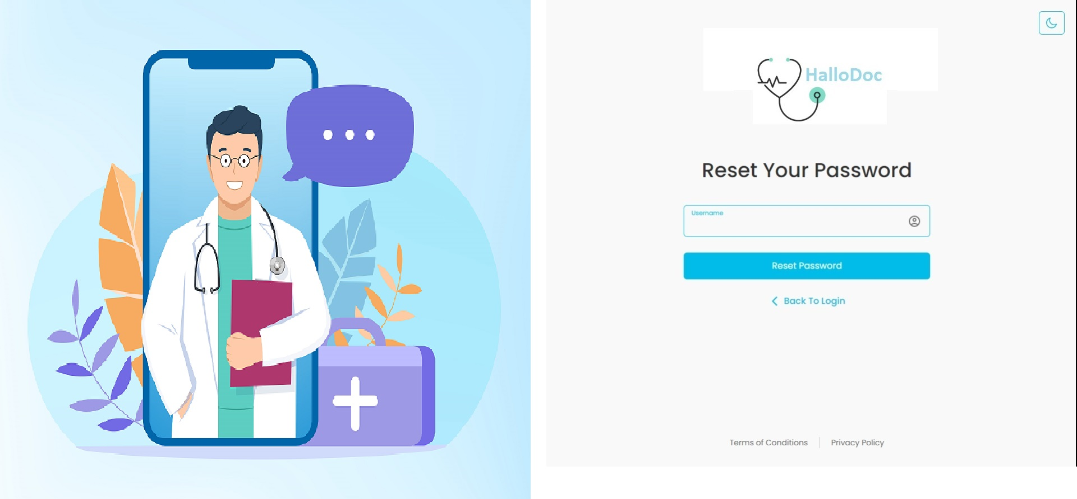

## Fig2. Forgot Password

**Description:**

Users who have forgotten their password may request it by entering their email address. The system will check their email address existence, if it exists then reset password link will be sent to their email address. Reset password link will expire in 24 hours.

**Features:**

|  |  |  |  |
| --- | --- | --- | --- |
| **#** | **Feature** | **Type** | **Description** |
|  | Email address | Input | User will need to enter his email address in this text box. |
|  | Reset password | Button | Clicking on this button, the system will check if entered email address exists or not in platform. If it exists then Reset Password link will be sent to this email address. |
|  | Back to Login | Link | Clicking on this link will redirect the user back to the login page. |

## Reset Password

**Description:**

Users will receive a link for this page via email when requested through forgot password page. When Page is loaded Link will be checked for expiration.

**Features:**

|  |  |  |  |
| --- | --- | --- | --- |
| **#** | **Feature** | **Type** | **Description** |
|  | Password | Input | Users will need to enter new password. |
|  | Confirm Password | Input | User will need to confirm the new password |
|  | Reset | Button | Clicking on this button, User can reset their password. |

**2. Admin Dashboard :**  
  
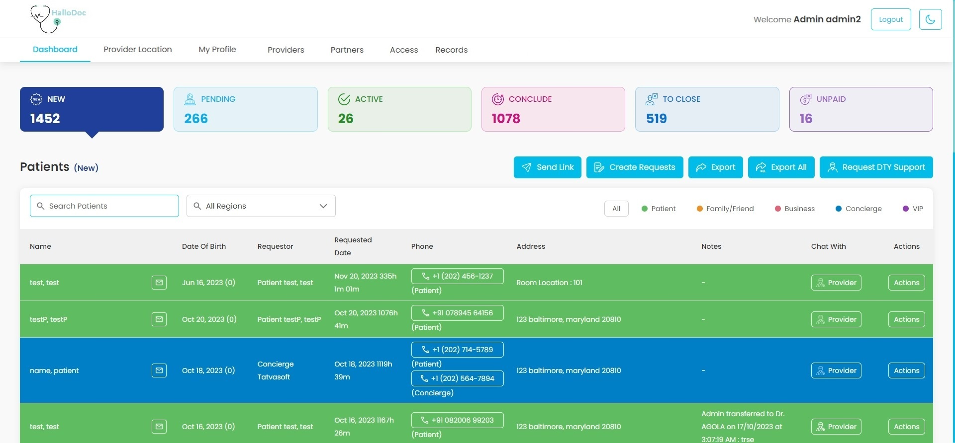s

Fig3. Admin Dashboard

**Description:**

Once the login is successfully completed, the Admin will be automatically directed to the platform's landing page, which will showcase the patient requests. The Admin will have the ability to filter the requests based on their request type and search for specific requests using the patient's name or the name of the requestor. On desktop devices, the requests can be viewed in a grid format, while on mobile devices, a card view will be provided for optimal display.

**Features:**

|  |  |  |  |
| --- | --- | --- | --- |
| **#** | **Feature** | **Type** | **Description** |
|  | NEW | Button | Clicking on this button, Admin can view all the newly created patient requests. |
|  | Pending | Button | Clicking on this button, Admin can view all patient requests which are accepted by provider and patients who do not have accepted the agreement. |
|  | Active | Button | Clicking on this button, Admin can view all requests for which patients have accepted the agreement or providers has choose House-call for providing the care. |
|  | Conclude | Button | Clicking on this button, Admin can view all requests for which providers have completed their service from their side. |
|  | To close | Button | Clicking on this button, Admin can view all requests which are ready to close. |
|  | Unpaid | Button | Clicking on this button, Admin can view all requests which are unpaid by patients. |
|  | Send Link | Button | Clicking on this button, Admin can send links to patients for creating a request via email and SMS. |
|  | Create Request | Button | Clicking on this button, Admin can create a request on behalf of the patient. |
|  | Export | Button | Clicking on this button, Admin can export an Excel file of the patient requests of current request state and current page or filtered requests. |
|  | Export All | Button | Clicking on this button, Admin can export an Excel file of all the patient requests. |
|  | Search Patients | Input | Admin can search patients by patient name, requestor name |

Admin dashboard in new state :  
  
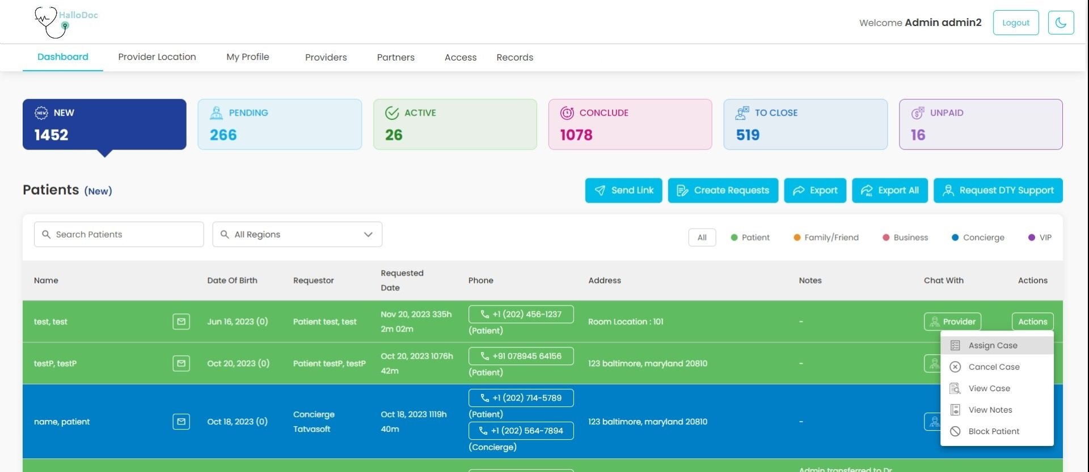

Fig4. Admin dashboard in new state

**Description:**

* The landing page will exhibit all recently created requests. Initially, when patients generate a request, those requests will appear in the "New" state on the Dashboard.

Admin dashboard in pending state:

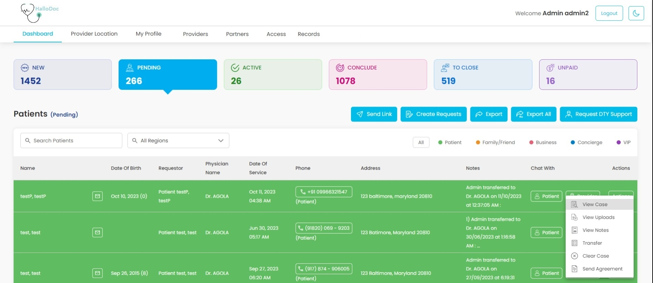

Fig5. Admin dashboard in pending state

**Description:**

The page will show patient requests that have been accepted by providers or are still pending the acceptance of the service agreement by patients. When providers accept a patient request, they are required to send an agreement video link via email and SMS to the patient's email address and phone number. Once the patient accepts the agreement, their request will transition from the "Pending" state to the "Active" state.

Admin dashboard in Active state:

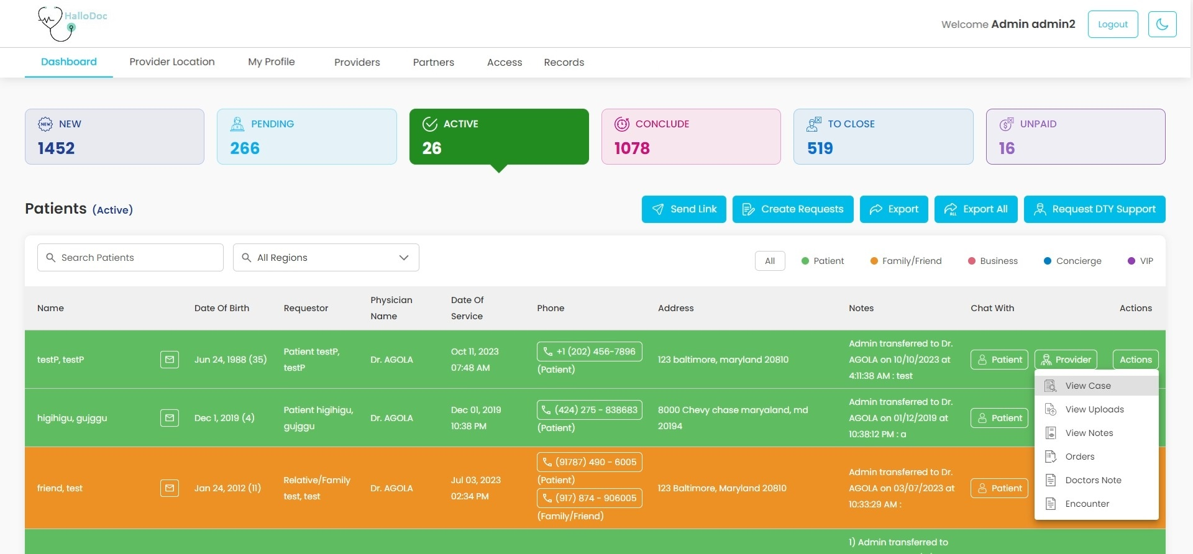  
 Fig6. Admin dashboard in Active state

This page will display patient requests for which patients have accepted the service agreement and provider is giving service to the patient. Once the request is transferred into active state providers can start medical care for the patients.

Admin dashboard in Conclude state:

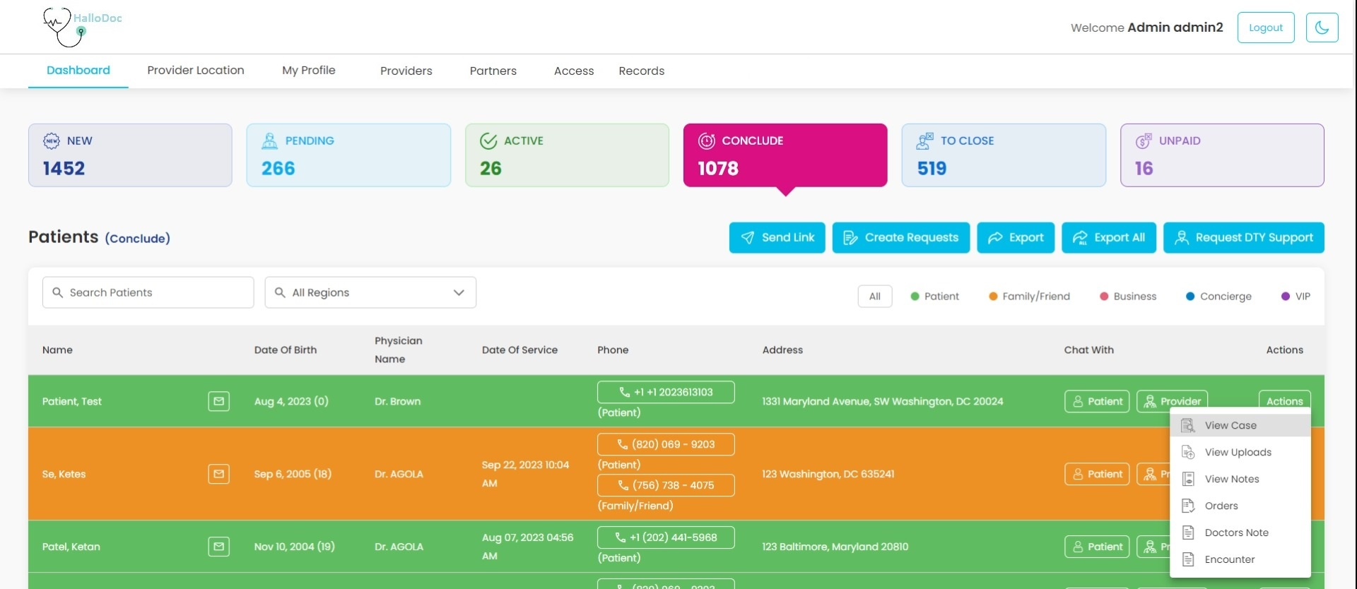

Fig7. Admin dashboard in Conclude state

This page will display patient requests for which medical is completed by the provider. Once the request is transferred into conclude state providers can finally conclude care for the patients.

Admin dashboard into Close state:

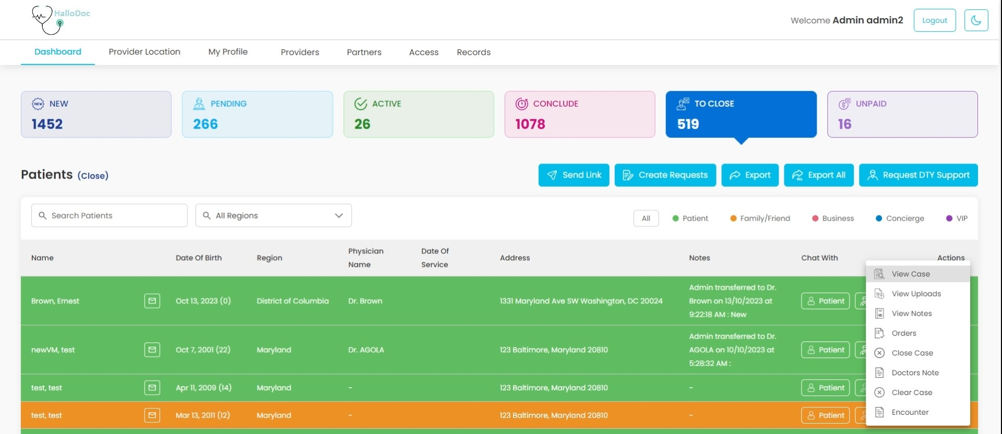

Fig8. Admin dashboard into Close state

This page will display all patient requests which are concluded by providers or cancelled by the admin. Admin can close the case.

Admin dashboard in Unpaid state:

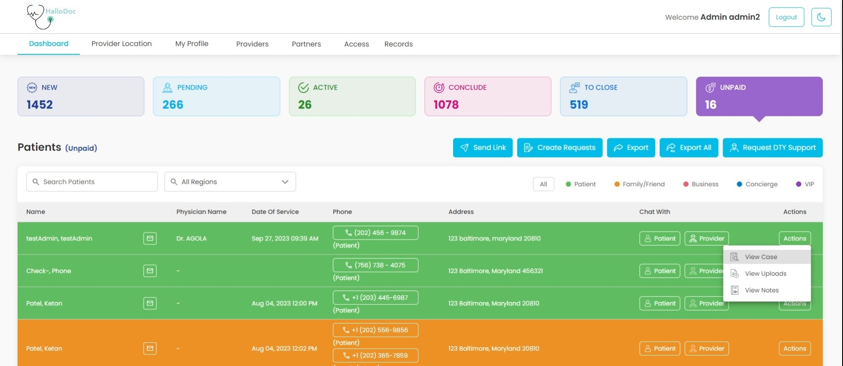

Fig9. Admin dashboard in Unpaid state

This page will display all closed patient requests for which patients have not paid the fees.

View case:

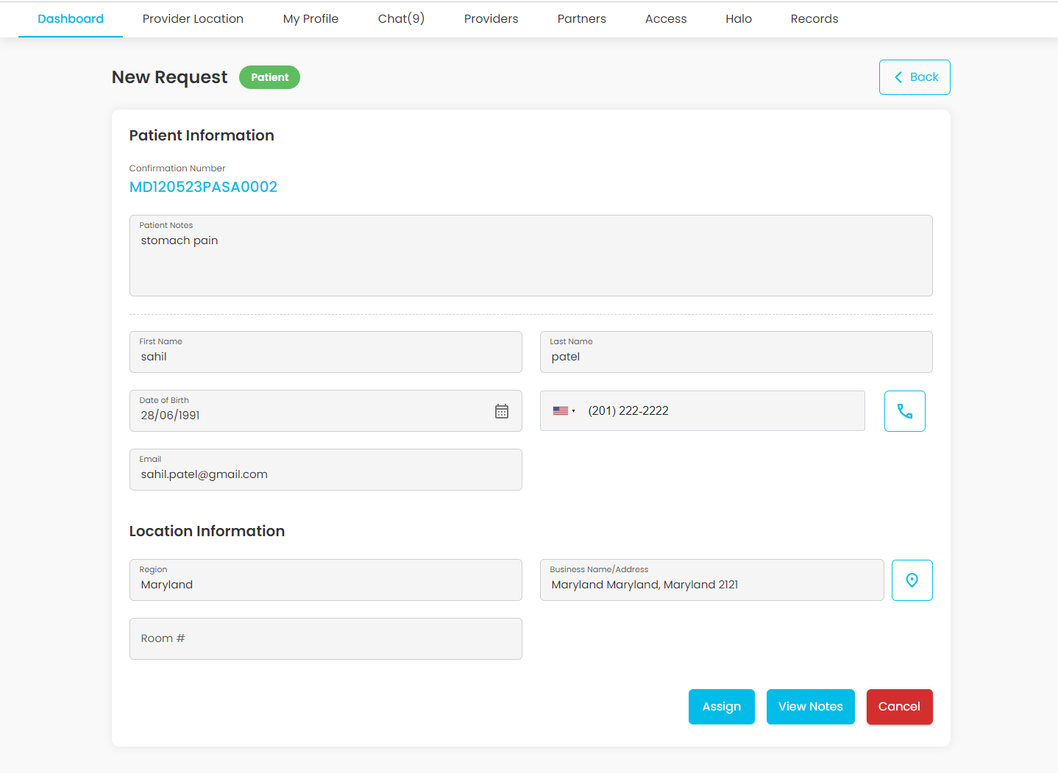

Fig10. View case

**Description:**

This page will display all the details of patient requests. Admin can view Patient’s personal information on this page.

**Features:**

|  |  |  |  |
| --- | --- | --- | --- |
| **#** | **Feature** | **Type** | **Description** |
|  | Confirmation Number | Label | It will show the confirmation number for patient request which was created at the time of submitting a request. It is created by the patient’s region and datetime of submitting a request. It will be unique for each patient. The first 2 characters will represent the region abbreviation, then next 4 numbers will represent the date of created date, then next 2 characters will represent first 2 characters of last name, then next 2 characters will represent first 2 characters of first name, then next 4 digits is representing how many requests are done in same day. |
|  | Patient Notes | Textbox | It will show the patient notes which are added by the patient at the time of creating a request. |
|  | First Name | Textbox | It will show the patient’s first name. |
|  | Last Name | Textbox | It will show the patient’s last name. |
|  | Date of birth | Textbox | It will show the patient’s date of birth. |
|  | Phone Number | Textbox | It will show the patient’s phone number. |
|  | Email | Textbox | It will show the patient’s email. |
|  | Edit | Button | Clicking on this button, admin will be able to edit Patient information. |
|  | Region | Textbox | It will show the patient’s region. |
|  | Business Name/Address | Textbox | It will show the patient’s address. |
|  | Room | Textbox | It will show the patient’s address. |
|  | Assign | Button | This button will only be visible in new state cases. Clicking on this button, admin can assign that request to the provider. |
|  | View Note | Button | Clicking on this button, admin will redirect to the View Notes page of that request. |
|  | Cancel | Button | Clicking on this button, admin can cancel the request and that request will be moved into “To Close” |
|  | Back | Button | Clicking on this button, admin will redirect to the previous page |

View Notes:

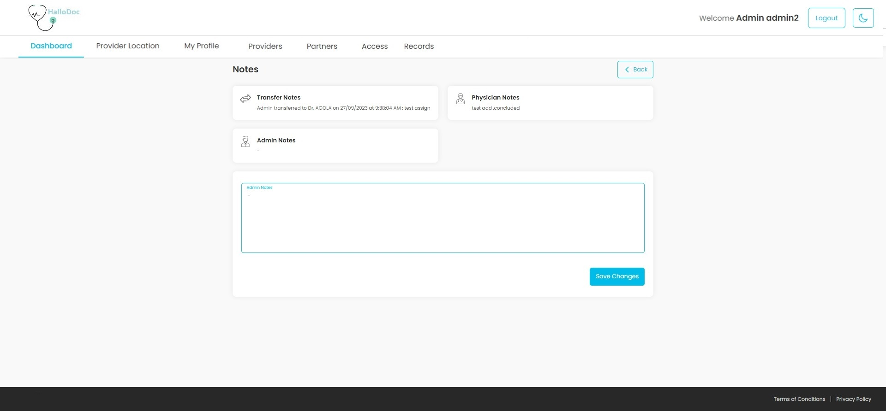

Fig11. View Notes

**Description:**

The page will present a variety of notes associated with the patient request. It includes seven note types: Patient Notes, Transfer Notes, Physician Notes, Admin Notes, Admin Cancellation Notes (shown when the admin cancels the request), Physician Cancellation Notes (shown when the provider cancels the request), and Patient Cancellation Notes (shown when the patient cancels the request).

**Features:**

|  |  |  |  |
| --- | --- | --- | --- |
| **#** | **Feature** | **Type** | **Description** |
|  | Transfer Notes | Textbox | It will show the transfer notes of the request with the date and time. When an admin has transferred to which provider on which date. |
|  | Physician Notes | Textbox | It will show the notes of the request provided by the physician. |
|  | Admin Notes | Textbox | It will show the notes of the request provided by admin |
|  | Additional Notes | Input | Admin can add any additional notes using this field. |
|  | Admin Cancellation Notes | Textbox | This section will be shown if there are any admin cancellation notes. It will show the reasons for canceling the request by admin. |
|  | Patient Cancellation Notes | Textbox | This section will show if there are any patient cancellation notes. It will show the reasons for cancelling the request by patient. |
|  | Save changes | Button | Clicking on this button, admin notes will be saved in database. |

Cancel case:

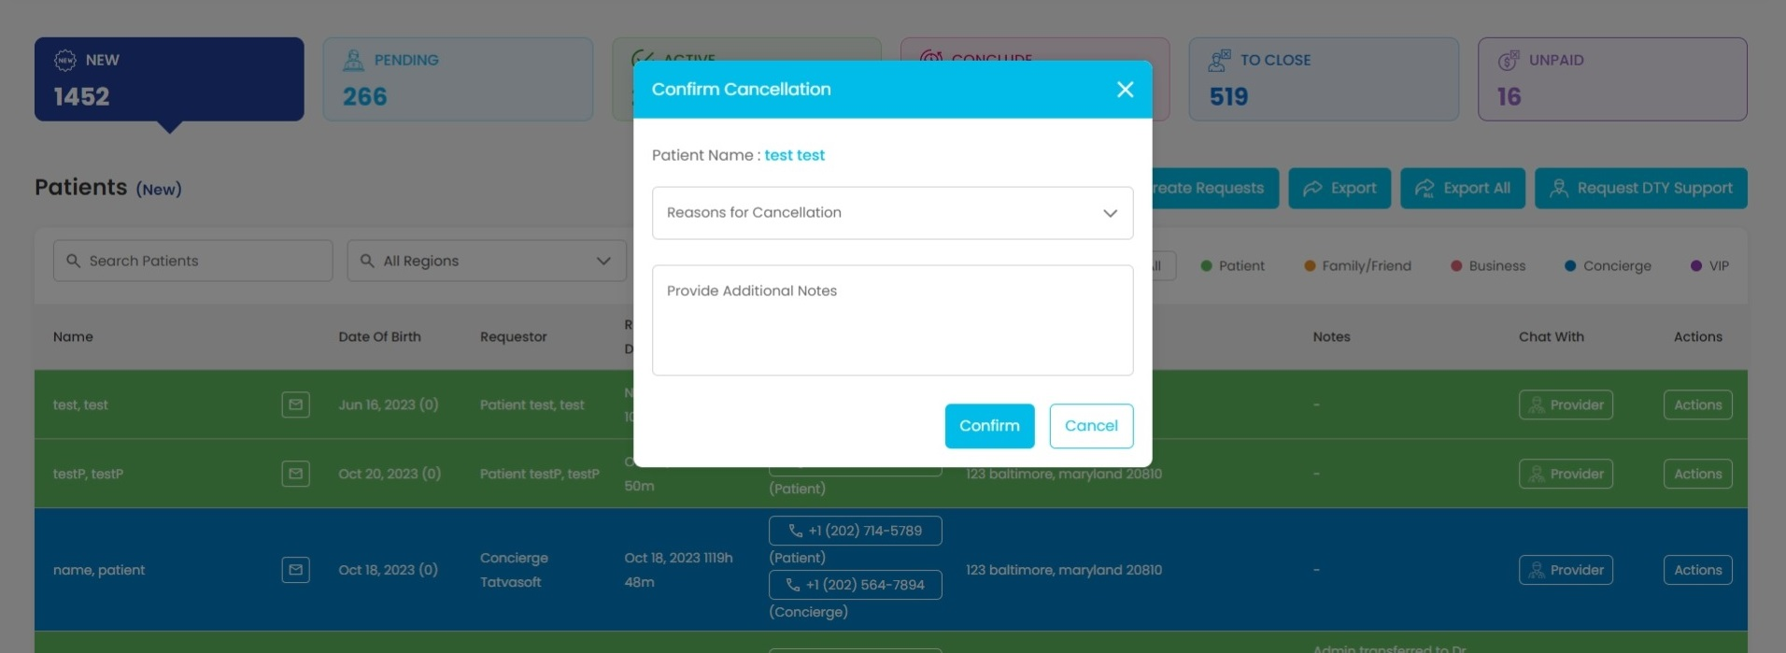

Fig12. Cancel Case pop-up

**Description:**

This pop-up will open when admin clicks on “Cancel case” link from Actions menu. Admin can cancel the request using this pop-up.

**Features:**

|  |  |  |  |
| --- | --- | --- | --- |
| **#** | **Feature** | **Type** | **Description** |
|  | Patient Name | Label | It will display the name of the patient. |
|  | Reasons for cancellation | Drop-down | It will display the reasons for cancellations. |
|  | Provide Additional notes | Textbox | Admin can provide some additional notes for cancellation. |
|  | Confirm | Button | Clicking on this button, admin will confirm to cancel the request. |
|  | Cancel | Button | Clicking on this button, admin can cancel the cancellation of request. |

Assign case:

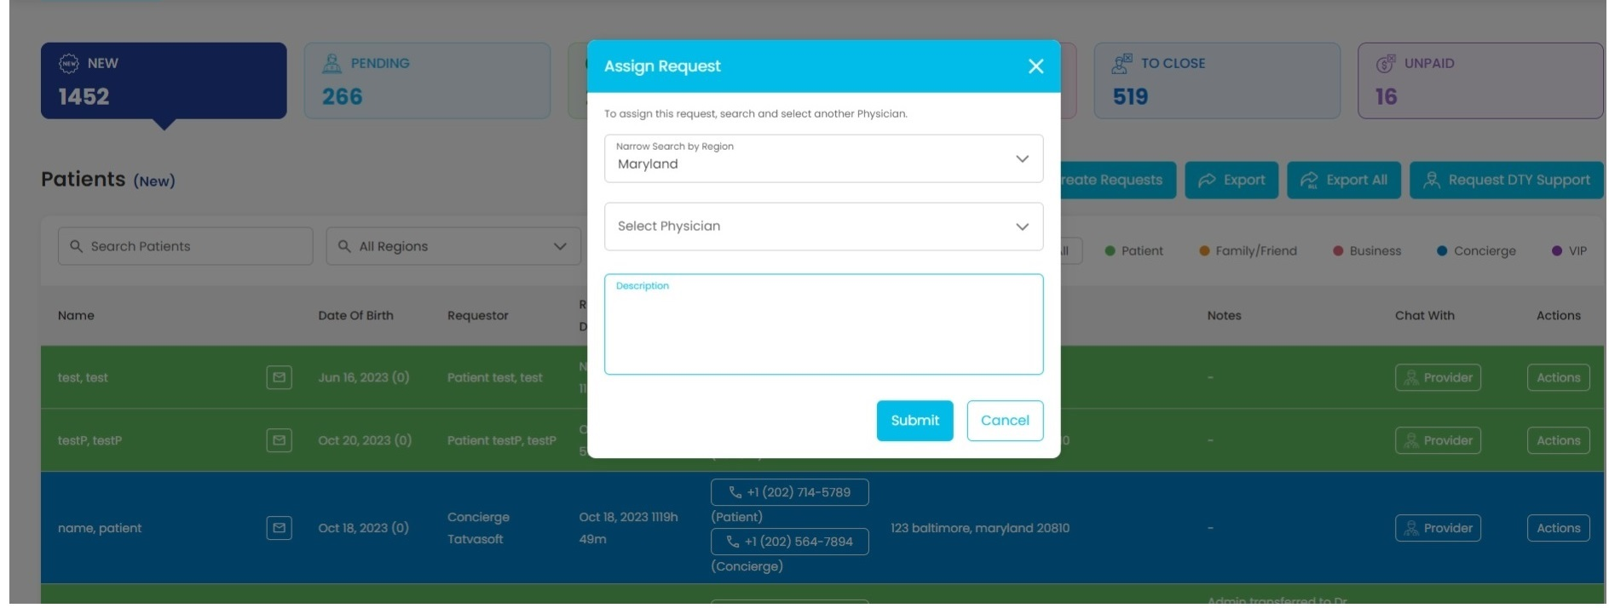

Fig13. Assign case

**Description:**

This pop-up will open when admin clicks on “Assign case” link from Actions menu. Admin can assign the case to providers based on patient’s region using this pop-up.

**Features:**

|  |  |  |  |
| --- | --- | --- | --- |
| **#** | **Feature** | **Type** | **Description** |
|  | Narrow search by region | Drop-down | It will display a list of states where this platform can provide the service. |
|  | Select Physician | Drop-down | It will display a list of available providers based on the selected state. |
|  | Description | Input | Admin can add additional description for patient request. |
|  | Submit | Button | Clicking on this button, admin will confirm the assign request. |
|  | Cancel | Button | Clicking on this button, admin will cancel the assign request. |

Block case pop-up:

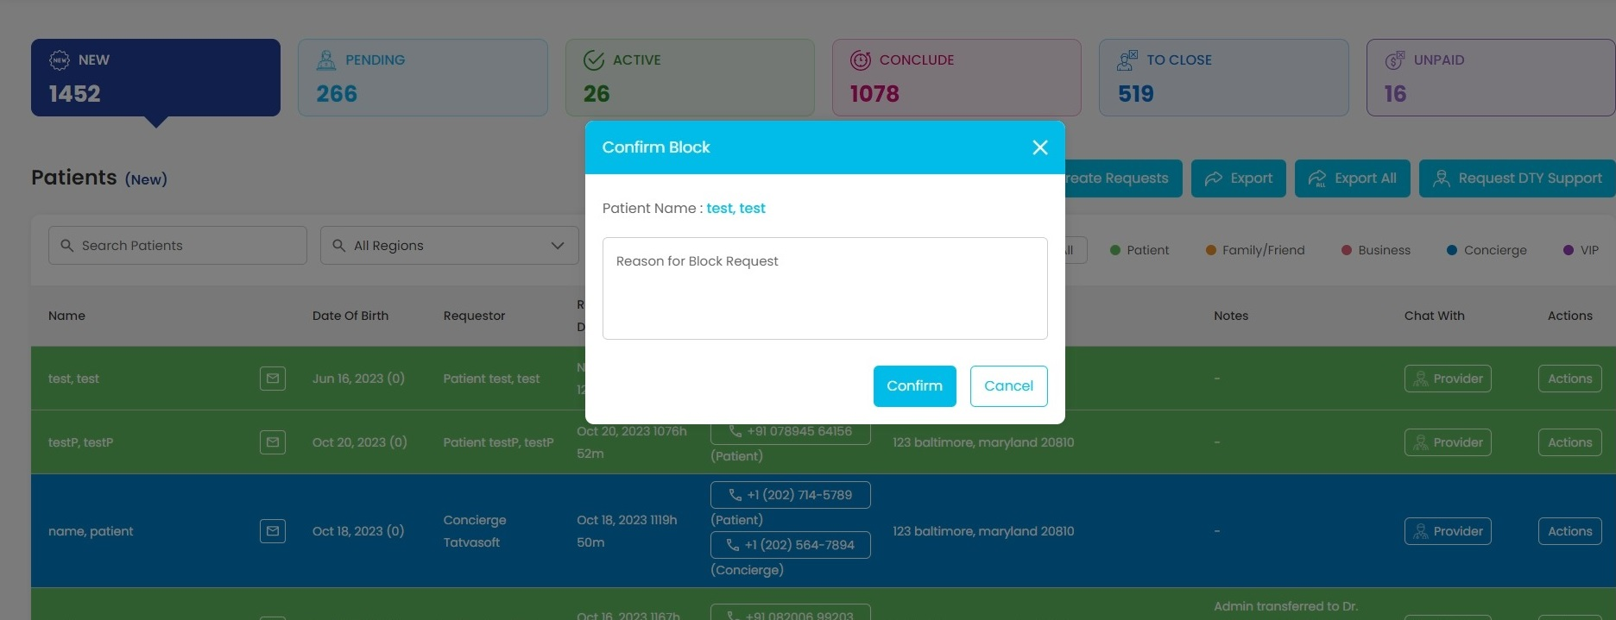

Fig14. Block case

**Description:**

This pop-up will open when admin clicks on “Block Case” link from Actions menu. From the new state, admin can block any case. All blocked cases can be seen in Block history page.

**Features:**

|  |  |  |  |
| --- | --- | --- | --- |
| **#** | **Feature** | **Type** | **Description** |
|  | Reason | Input | Admin needs to enter a reason for blocking the case. |
|  | Confirm | Button | Clicking this button, Admin can block the case. |
|  | Cancel | Button | Clicking on this button will close the pop-up. |

View Uploads:

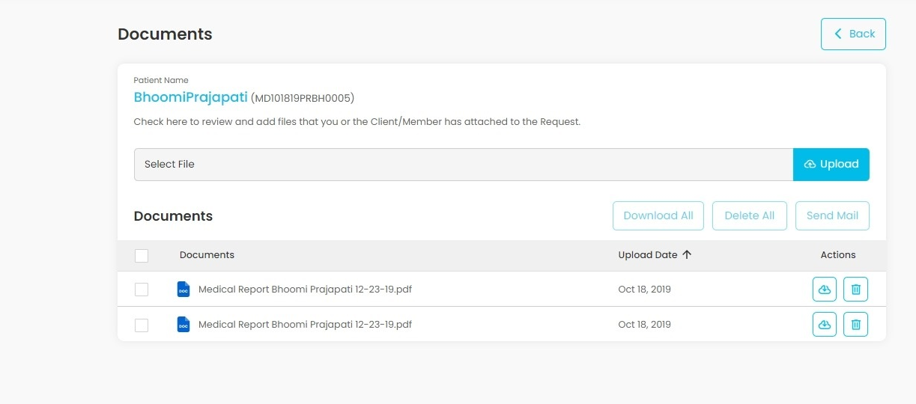

Fig15. View Uploads

**Description:**

This page will display all the documents uploaded by patients and admin/providers in pending state.

**Features:**

|  |  |  |  |
| --- | --- | --- | --- |
| **#** | **Feature** | **Type** | **Description** |
|  | Select File | File Upload | It will be used to select the file from the computer to upload. |
|  | Upload | Button | To upload the selected file. |
|  | Download All | Button | It will download all the selected files. |
|  | Delete All | Button | It will delete all the selected files. |
|  | Send Mail | Button | It will send the selected files via email. To patient’s email address. |

Send Order:

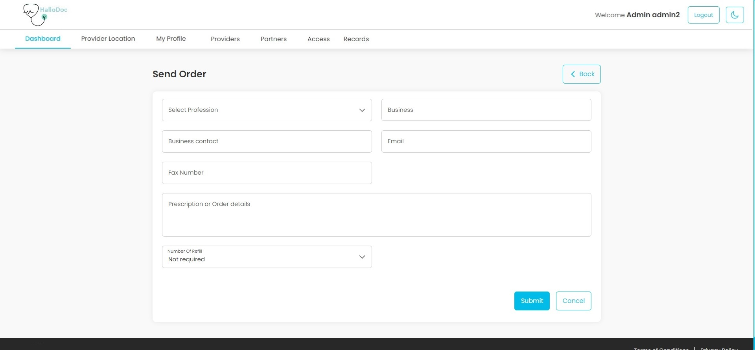

Fig16. Orders

**Description:**

This page will open when admin/provider will click on “Orders” link from Actions menu. From the active, conclude and close state, admin/providers can send order to a registered business.

**Features:**

|  |  |  |  |
| --- | --- | --- | --- |
| **#** | **Feature** | **Type** | **Description** |
|  | Select Profession | Dropdown | Admin/Provider needs to select a profession first to fetch related vendors. |
|  | Business | Dropdown | Admin/Provider needs to select a registered business (Vendor) for selected profession. |
|  | Business Contact | Input | It will show business contact of selected business. Admin/provider can edit business contact. |
|  | Email | Input | It will show the email of selected business. Admin/provider can edit the email. |
|  | Fax Number | Input | It will show the fax number of selected businesses. Admin/provider can edit the fax number. |
|  | Prescription or Order Details | Input | Admin/Provider needs to enter order details to send order. |
|  | Number of Refills | Dropdown | Admin/Provider can select how many times an order has to be refilled. |
|  | Submit | Button | Clicking on this button, Admin/Provider can send the order to selected business. |
|  | Cancel | Button | Clicking on this button, Admin/Provider will be redirected to Dashboard page. |
|  | Back | Button | Clicking on this button, Admin/Provider will be redirected to Dashboard page. |

Transfer Request pop-up:

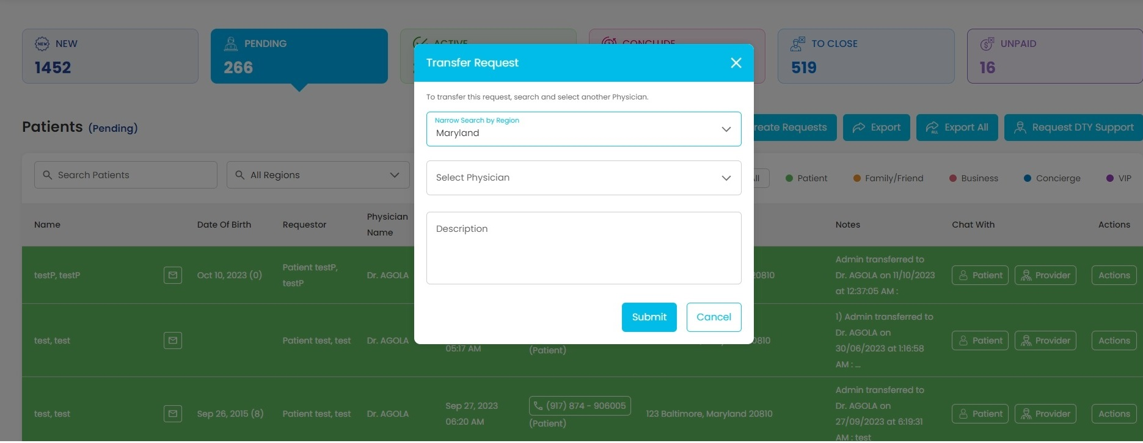

Fig17.Transfer

**Description:**

This pop-up will open when admin clicks on “Transfer” link from Actions menu. From the pending state, admin can transfer assigned request to another physician.

**Features:**

|  |  |  |  |
| --- | --- | --- | --- |
| **#** | **Feature** | **Type** | **Description** |
|  | Region | Dropdown | Admin can search physician by selecting one region. |
|  | Physician | Dropdown | Admin needs to select Physician to whom request is transferring. |
|  | Description | Input | Admin can enter a note for transfer. |
|  | Submit | Button | Clicking on this button, Admin can transfer requests from assigned physician to different physician. |
|  | Cancel | Button | Clicking on this button will close this pop-up. |

Clear case pop-up:

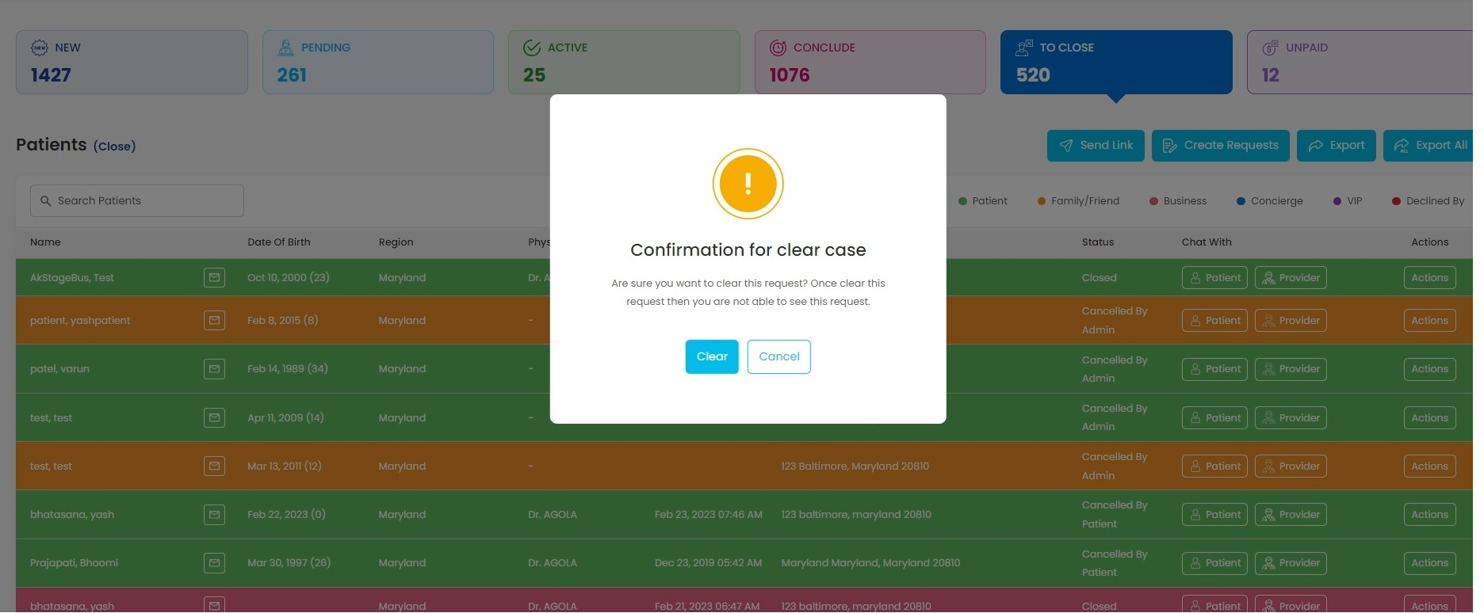

Fig18.Clear Case

**Description:**

This pop-up will open when admin clicks on “Clear case” link from Actions menu. From the pending and close state, admin can clear the case from the action grid.

**Features:**

|  |  |  |  |
| --- | --- | --- | --- |
| **#** | **Feature** | **Type** | **Description** |
|  | Clear | Button | Clicking on this button, Admin can clear the case. |
|  | Cancel | Button | Clicking on this button will close the pop-up. |

Send Agreement pop-up:

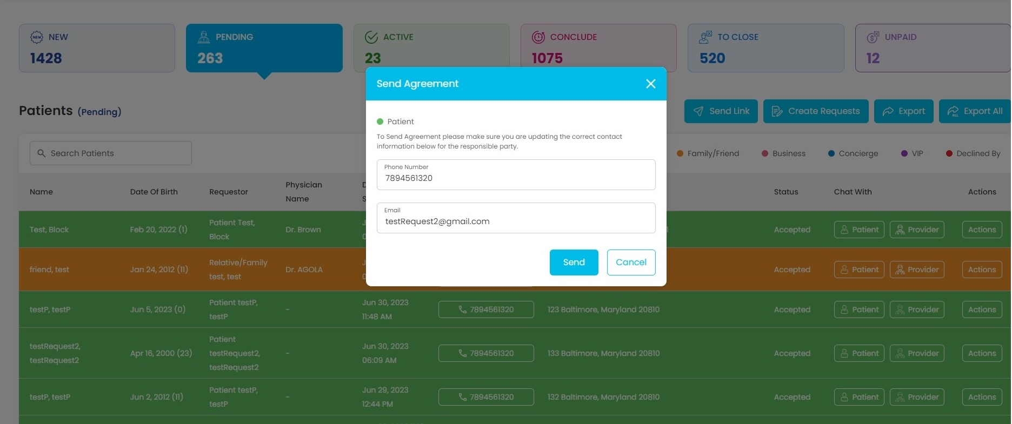

Fig19. Send Agreement pop-up

**Description:**

This pop-up will open when admin/provider will click on “Send agreement” link from Actions menu. From the pending state, providers need to send an agreement link to patients.

**Features:**

|  |  |  |  |
| --- | --- | --- | --- |
| **#** | **Feature** | **Type** | **Description** |
|  | Phone number | Input | It will show patient's phone number |
|  | Email | Input | It will show patient's Email address |
|  | Send | Button | Clicking on this button, admin can send agreement to the patient. |
|  | Cancel | Button | Clicking on this button, send agreement pop-up will close. |

Close case:

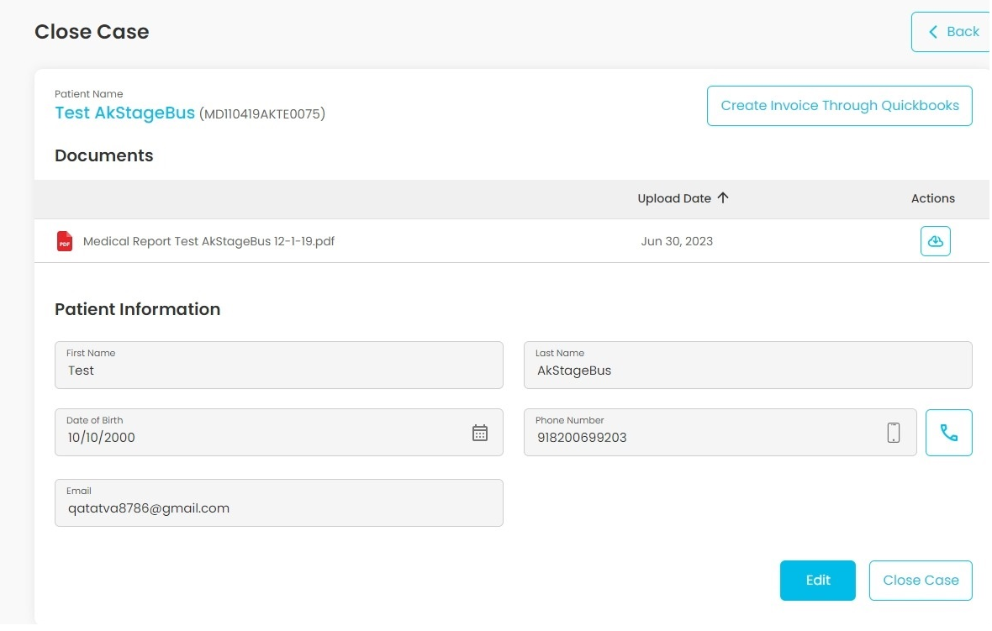

Fig20. Close case

**Description:**

This page will open when the admin clicks on “Close case” link from Actions menu from to close state.

**Features:**

|  |  |  |  |
| --- | --- | --- | --- |
| **#** | **Feature** | **Type** | **Description** |
|  | Create Invoice through Quick books | Button | Clicking on this button, Admin can create invoice for service using Quick books. **Good to have feature** |
|  | Action | Button | Clicking on this button, Admin can download a particular uploaded document. |
|  | Patient Name | Label | It will show full name of the patient |
|  | First Name | Textbox | It will show first name of the patient |
|  | Last Name | Textbox | It will show last name of the patient |
|  | Date of birth | Textbox | It will show date of birth of the patient |
|  | Phone number | Textbox | It will show phone number of the patient |
|  | Email | Textbox | It will show email of the patient |
|  | Edit | Button | Clicking on this button will enable the input field for Phone number and email, then it will show Save and cancel buttons instead of Edit and Close case buttons.  Admin can edit patient’s phone-number and email using this button. |
|  | Close Case | Button | Clicking on this button, admin can close the case and that request will be moved into "Unpaid" |
|  | Save | Button | Clicking on this button will save changed phone number and email values, then it will show Edit and Close case buttons instead of Save and Cancel buttons, also it will disable the phone number and email fields. |

Profile menu:

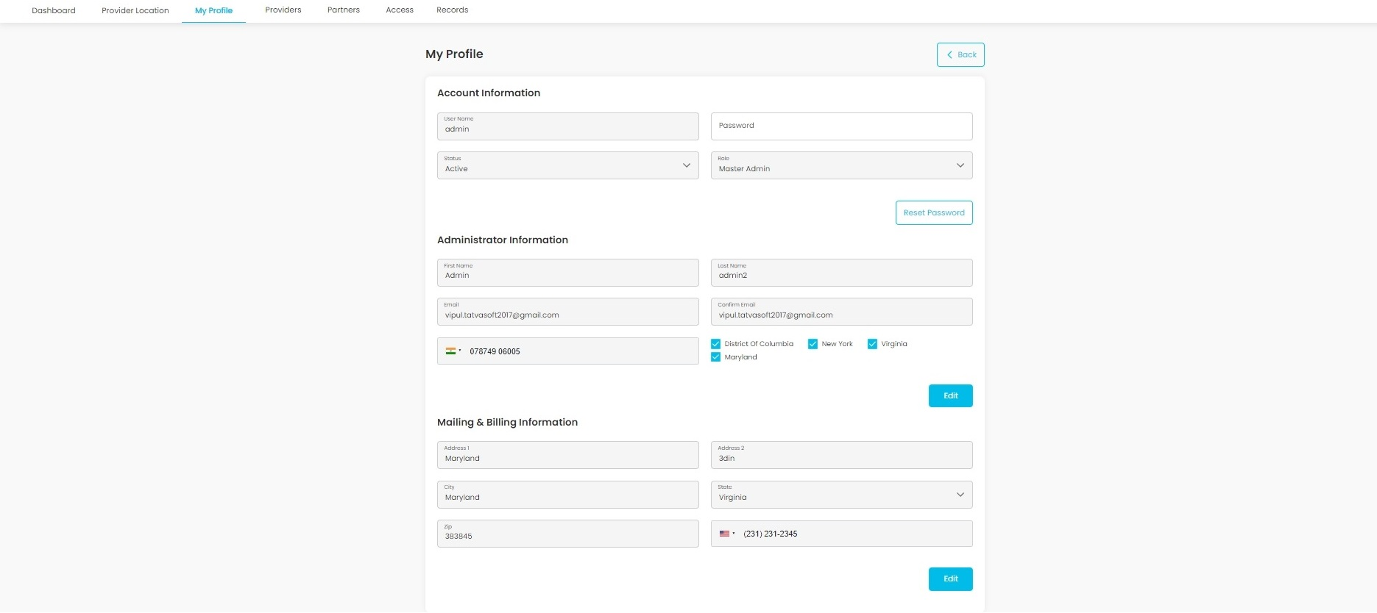

Fig21. My Profile

**Description:**

This page will show a profile for logged in admin. Admin can edit their information from this page. For the admin's My Profile page, if the admin wants to edit his/her profile, he/she can directly edit the details in their profile without requiring any additional approval.

Regions

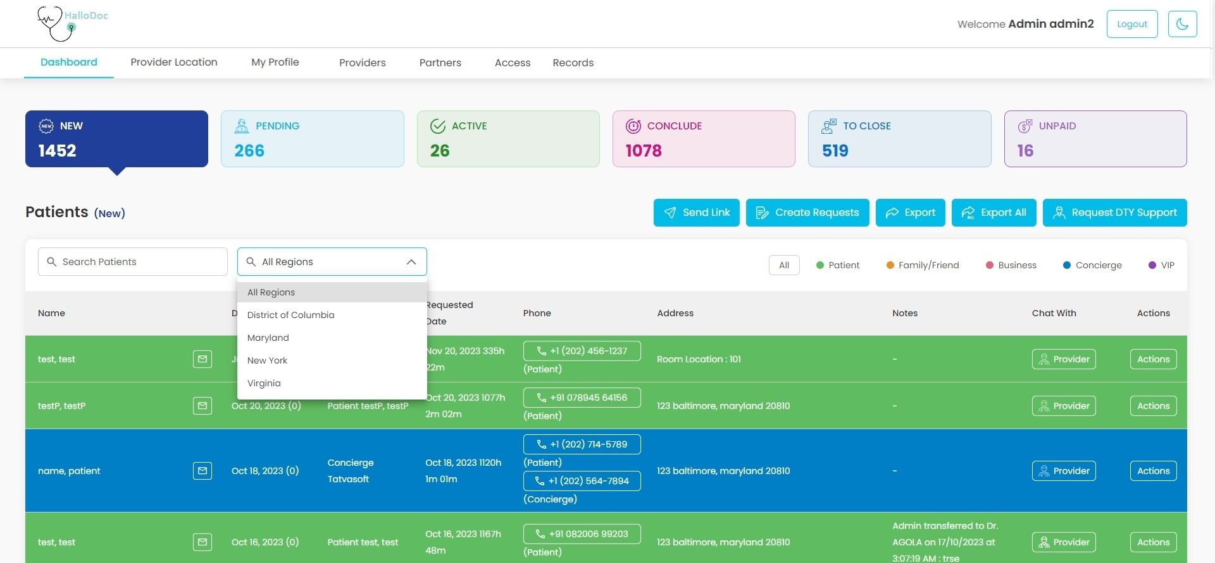

Fig22. Regions

**Description:**

In dashboard page Admin can filter requests using Region's filter. By default, requests of All regions will be fetched.

Request Support:

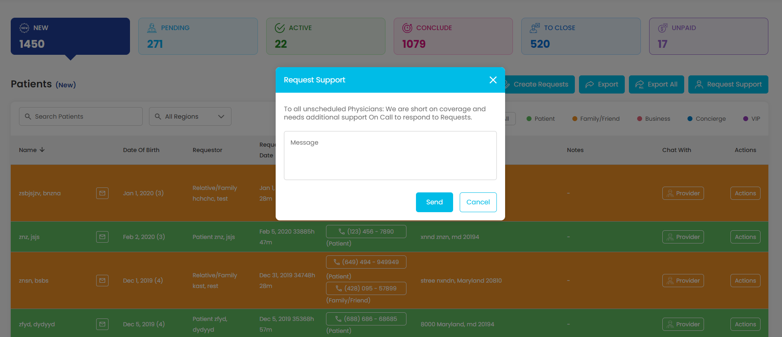

Fig23.Request Support

**Description:**

This popup is used for Sending message to all unscheduled Physicians.

**Features:**

|  |  |  |  |
| --- | --- | --- | --- |
| **#** | **Feature** | **Type** | **Description** |
|  | Message | Textbox | Admin will need to enter a message that will be sent to all unscheduled physicians. |
|  | Send | Button | Clicking on this button will send the entered message to all unscheduled physicians. |
|  | Cancel | Button | Clicking on this button will close Request DTY Support modal. |

Provider Menu:

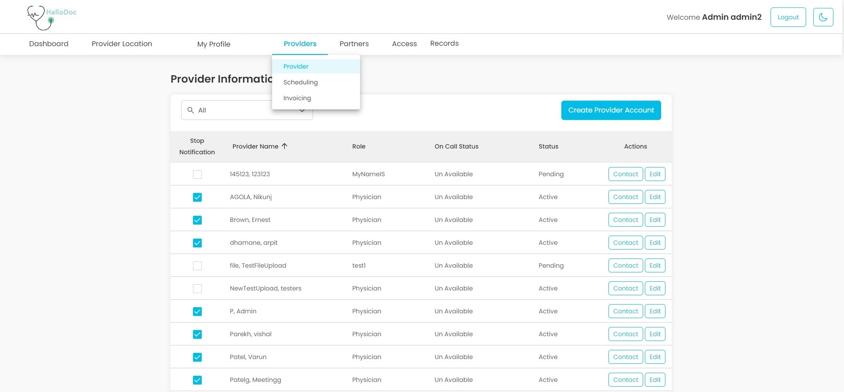

Fig24. Provider Menu

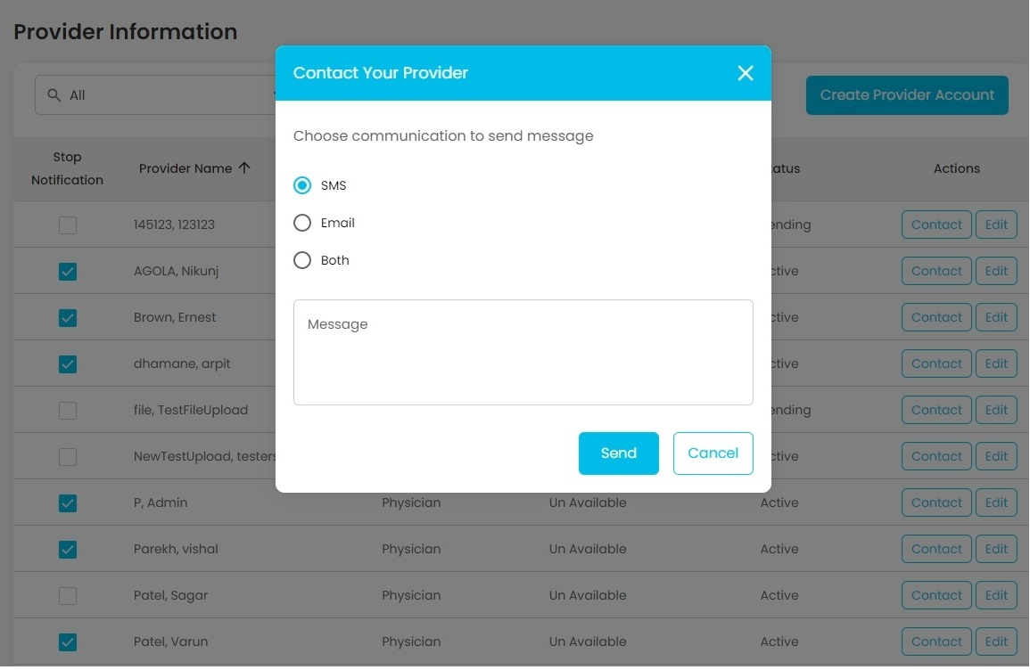

Fig25. Contact your Provider

By clicking the Contact button this pop-up will appear to the admin. Using this pop-up admin can send notification to provider by selected communication type (SMS, Email or Both) with a message.

**Description:**

This menu from header navbar contains 3 sub-menus: Provider, Scheduling, **Invoicing (Good to have feature)**.

**Features:**

|  |  |  |  |
| --- | --- | --- | --- |
| **#** | **Feature** | **Type** | **Description** |
|  | Search | Dropdown | Admin can filter provider list based on region |
|  | Create Provider Account | Button | By Clicking on this, Admin can create new Provider account from Create Provider Account Page |
|  | Stop notification | Checkbox | This checkbox will determine that provider will receive any notification or not. When any change is made, the Save button will appear. |
|  | Provider name | Text | This column will show Provider name |
|  | Role | Text | This column will show Provider’s role on the Website |
|  | On call status | Text | This column will show Provider’s On call status: Un Available, On call, and Busy |
|  | Status | Text | This column will show Provider’s Account Status: Pending, Active and Not active |
|  | Action | Button | By clicking on this button, a menu will open, which has two sub menus.  Contact Button: On clicking this button, contact your Provider pop up will open.  Edit Button: On clicking this button Edit Physician Account page will be opened. |

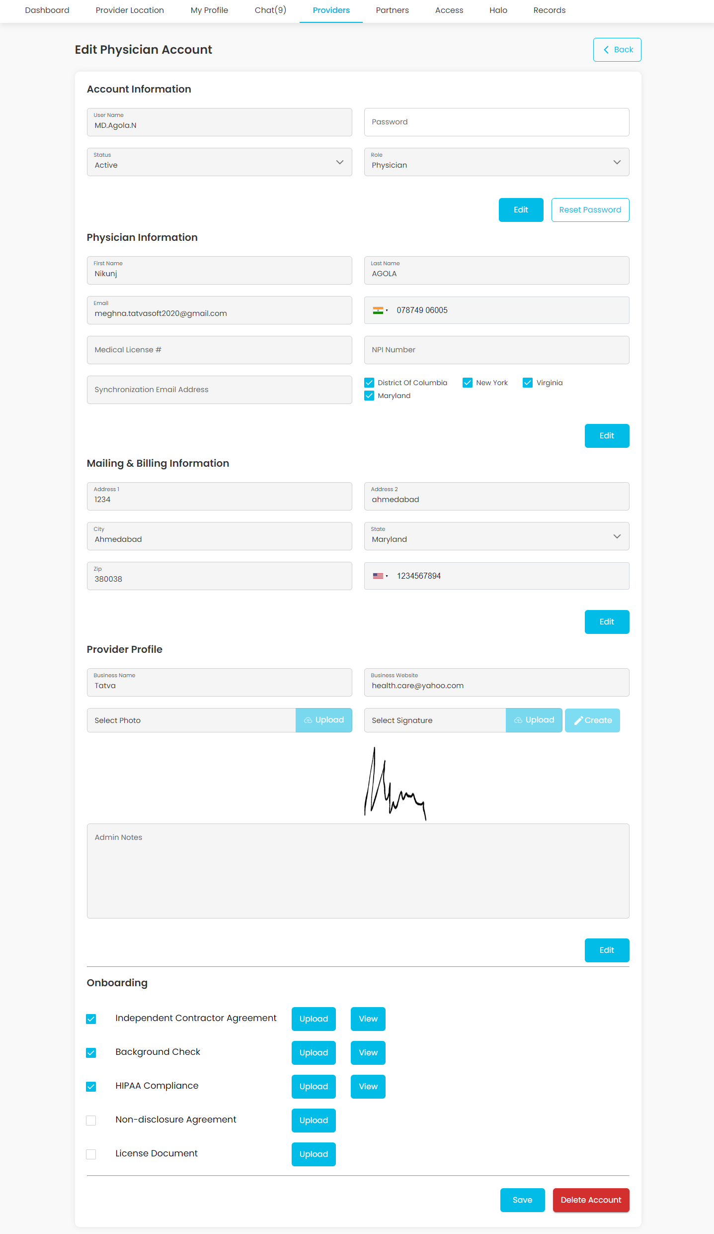

Fig26. Edit Physician Account

**Description:**

Through this page, Admin can edit provider (Physician) details, change their password. Upload documents and images related to the provider and delete their account.

**Features:**

|  |  |  |  |
| --- | --- | --- | --- |
| **#** | **Feature** | **Type** | **Description** |
|  | Username | Input | This input field will show the admin physician’s username. This field will be disabled always. |
|  | Password | Input | Admin can change account password using this field. |
|  | Status | Dropdown | Admin can change physician status using this field. Status values are: Pending, Active and Not Active. |
|  | Role | Dropdown | Admin can assign any physician Role to the account. |
|  | Edit | Button | By clicking this button in a particular form section, a field will be enabled in that form section. And “Save” and “Cancel” button will replace “Edit” button. |
|  | Reset password | Button | By clicking this button, admin can change physician account password with password entered in “Password” field. |
|  | Save | Button | By clicking this button all the data will be saved except password in the database. |
|  | Cancel | Button | By Clicking this button, all fields will become disabled without saving anything in database. |
|  | First Name | Input | Admin can change physician’s first name using this field. |
|  | Last Name | Input | Admin can change physician’s last name using this field. |
|  | Email | Input | Admin can change physician’s Email using this field. |
|  | Phone Number | Input | Admin can change physician’s phone using this field. |
|  | Medical License | Input | Admin can change physician’s medical license number using this field. |
|  | NPI Number | Input | Admin can change physician’s NPI (National Provider Identifier) number using this field. |
|  | Synchronization Email | Input | Admin can change physician’s Synchronization number using this field. |
|  | Regions | Checkboxes | Admin can select one or more regions for physician. (At least one required.) |
|  | Address1 | Input | Admin can change physician’s Address1 using this field. |
|  | Address2 | Input | Admin can change physician’s Address2 using this field. |
|  | City | Input | Admin can change physician’s city using this field. |
|  | State | Dropdown | Admin can select physician’s state using this dropdown. |
|  | Zip | Input | Admin can change Zip code associated with physician’s address. |
|  | Alternate Phone | Input | Admin can change physician’s alternate phone number. |
|  | Business name | Input | Admin can change physician’s business name using this field. |
|  | Business Website | Input | Admin can change physician’s business website using this field. |
|  | Photo | File Upload | Admin can upload physician’s profile photo using this field. |
|  | Signature | File Upload | Admin can upload physician’s signature using this field. |
|  | Admin Notes | Input | Admin can add any notes regarding what updates are done to the profile. |
|  | Delete Account | Button | By clicking on this button, admin can delete physician’s account. |

Access/Roles:

Account Access:

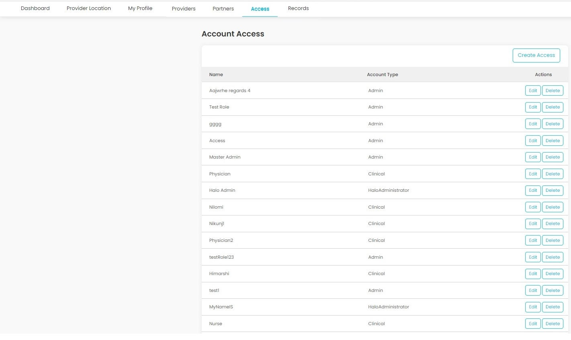

Fig27. Roles/Access

**Description:**

This page will show all the roles available on the platform. Admin can add, edit or delete any role. On add and edit admin can change access for the role.

**Features:**

|  |  |  |  |
| --- | --- | --- | --- |
| **#** | **Feature** | **Type** | **Description** |
|  | Create Access | Button | Clicking on this button, admin will be redirected to create role page. |
|  | Name | Table Header | It will show role name |
|  | Account Type | Table Header | It will show account type associated with role |
|  | Edit | Button | Clicking on this button, admin will be redirected to edit role page for particular role. |
|  | Delete | Button | Clicking on this button, Admin can delete any role by confirming through confirmation pop-up |

After clicking the Create Access button this page will be shown to the admin. Admin can create any role by choosing Account Type and Selecting page access through checkboxes.

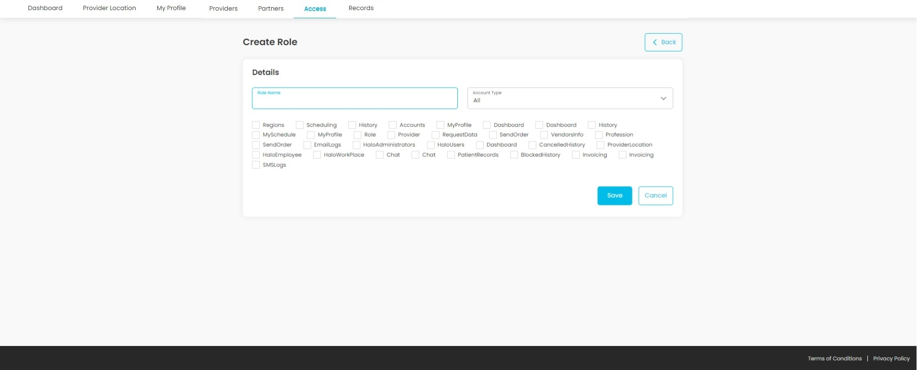

Fig28. Create Role All

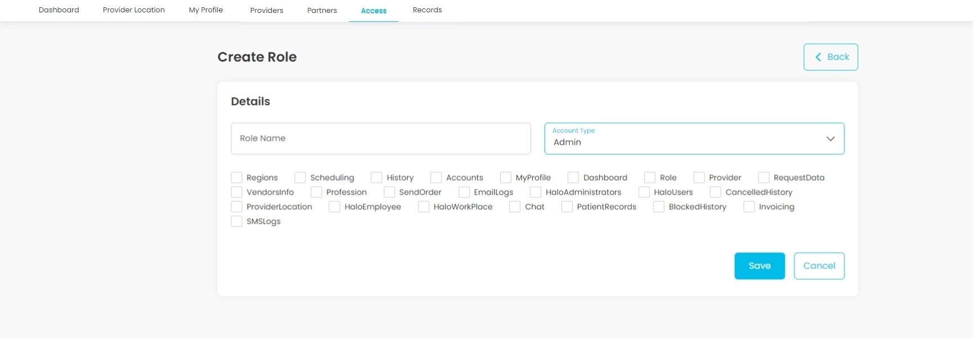

Fig29. Create Role Admin

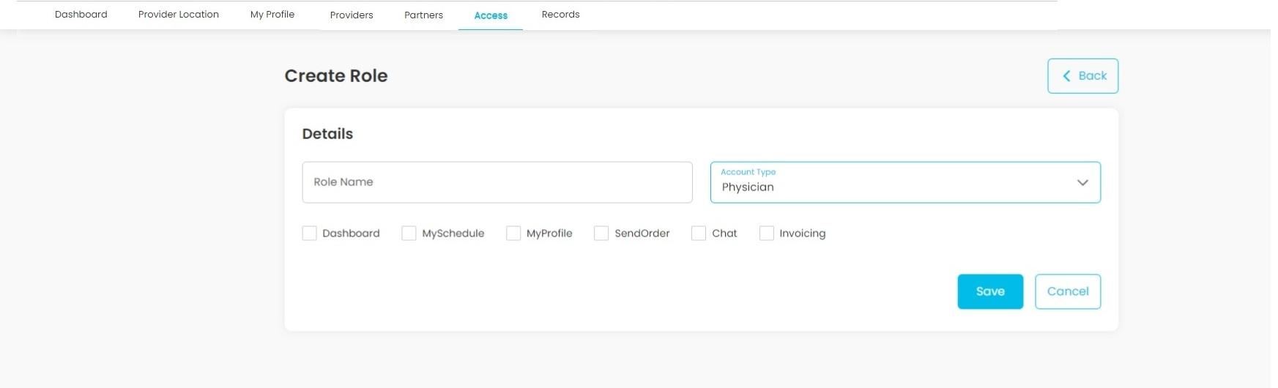

Fig30. Create Role Physician

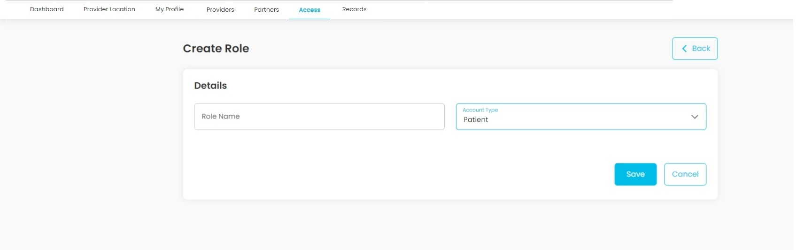

Fig31. 1 Create Role Patient

User Access:

**Description:**

This page will show all the registered users of this platform. Admin can edit any account

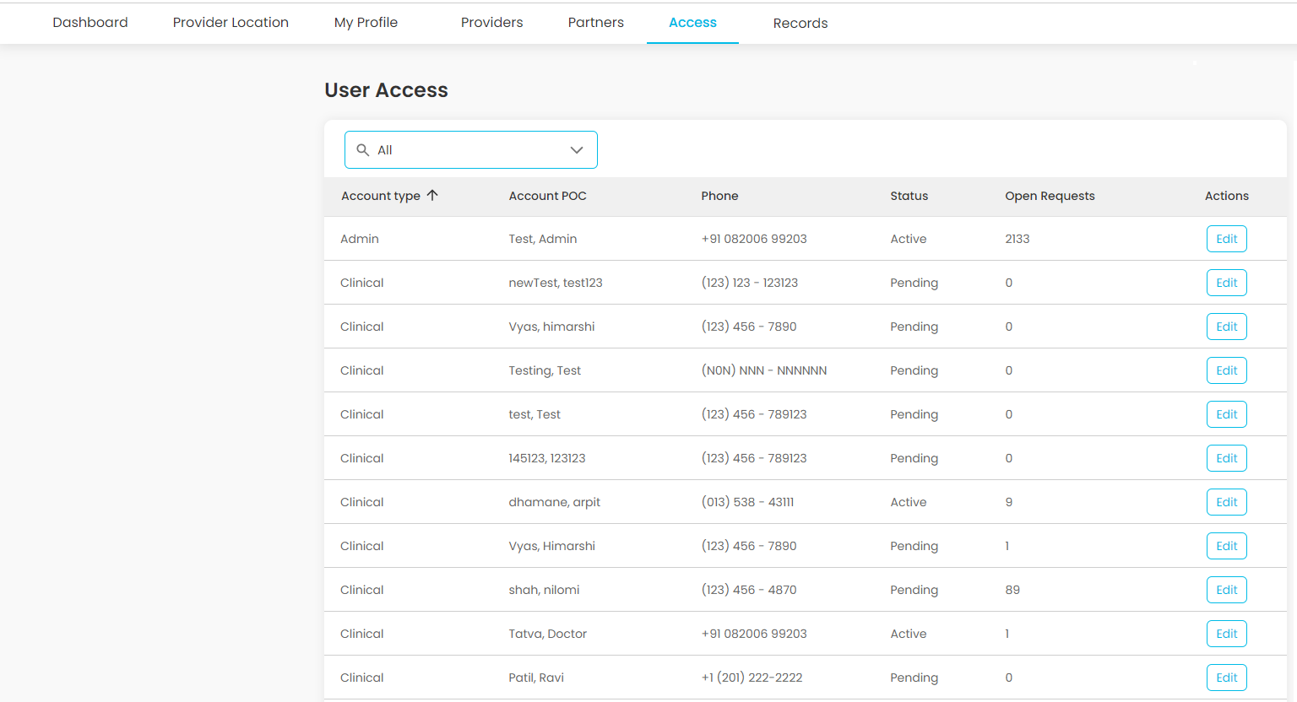

Fig31.2 Create Role Patient

**Features:**

|  |  |  |  |
| --- | --- | --- | --- |
| **#** | **Feature** | **Type** | **Description** |
|  | Search | Search box | Admin can search any account by role type |
|  | Edit | Button | Clicking on this button will redirect admin to edit account page for particular account |

Scheduling:

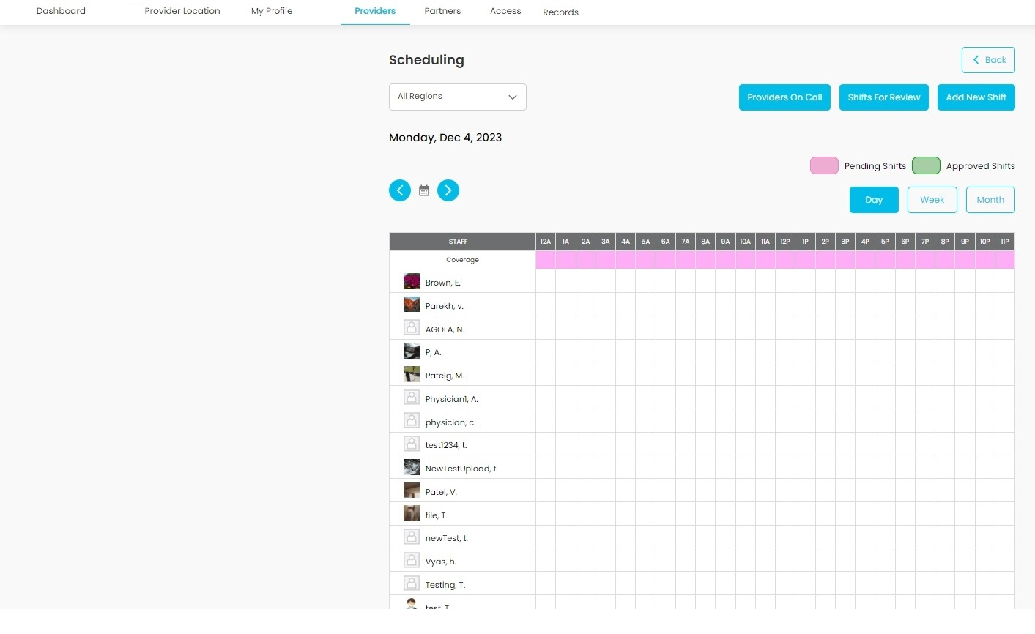

Fig32. Day wise Scheduling

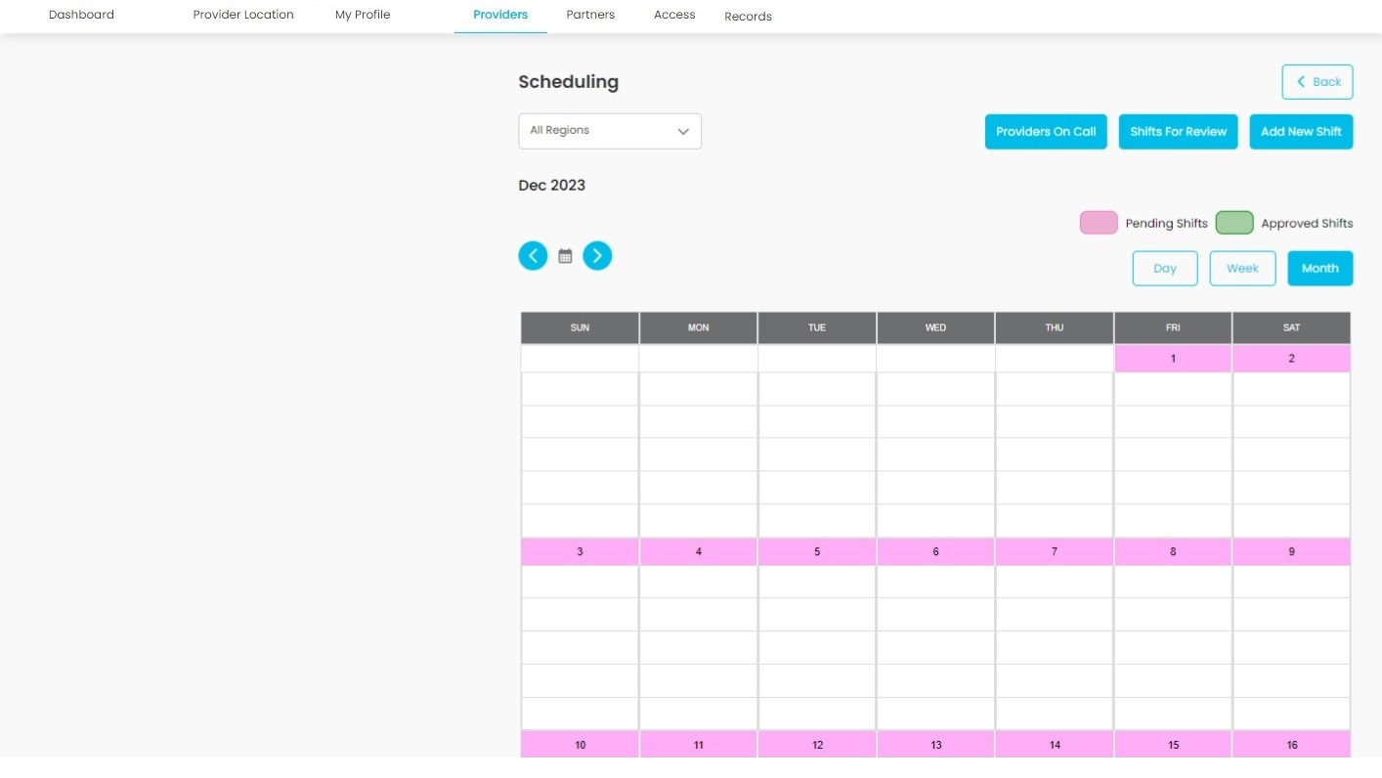

Fig33. Month wise Scheduling

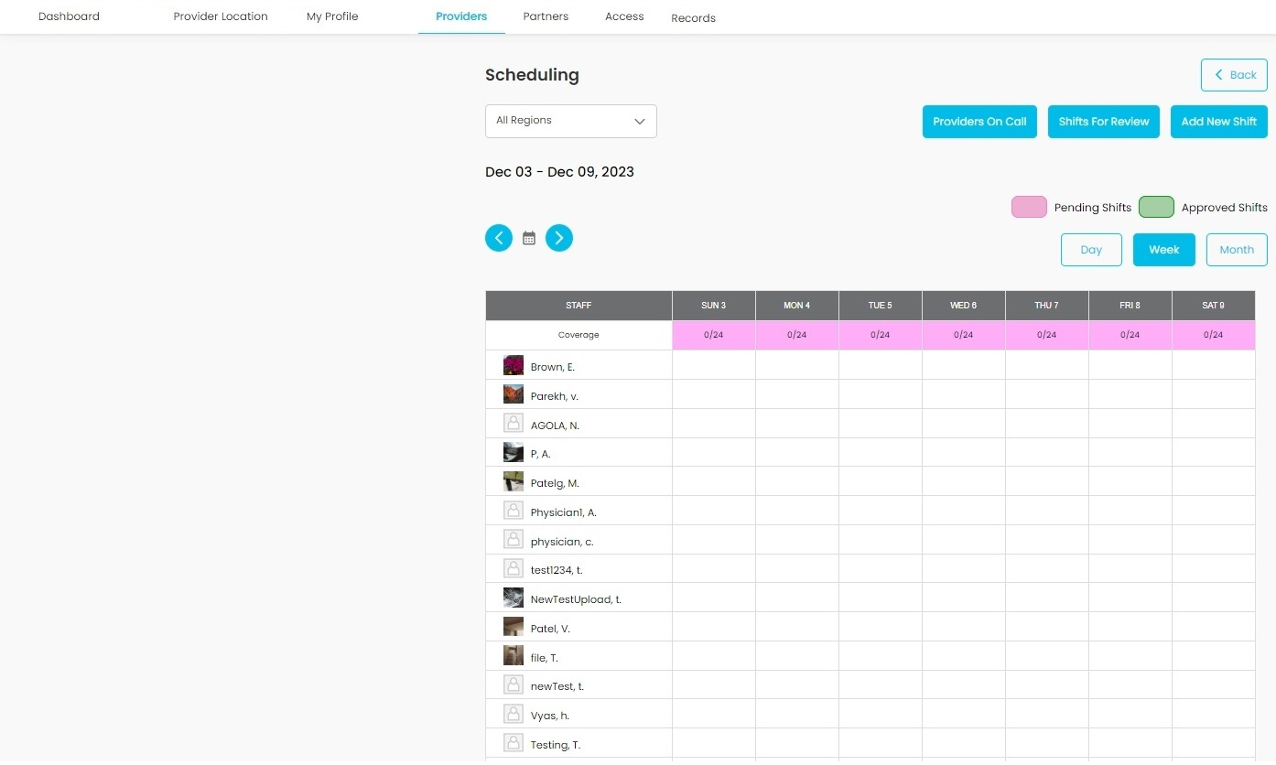

Fig34. Week wise Scheduling

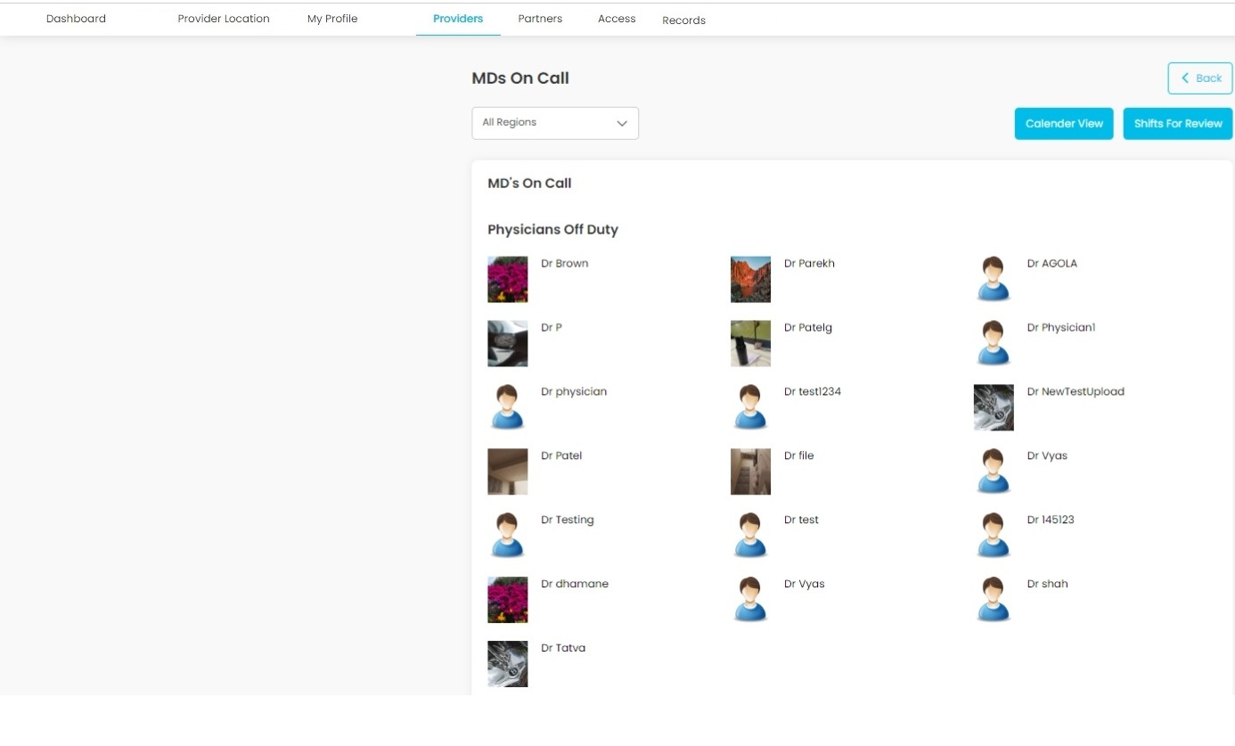

Fig35. Provider on call (MDs On Call)  
  
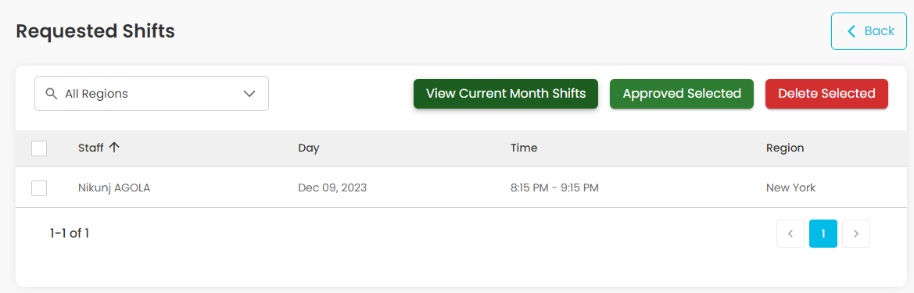

Fig36. Requested Shift

**Description:**

This page will allow Admin to review provider’s shifts, add new shifts, providers on call based on selected region by weekly, monthly or daily in a calendar view. It’s connected to Google calendar so Admin/Providers will get Google reminder of their scheduled shifts. All the shifts which are approved by admin will be colored green color and those which are not approved by admin will be colored with red color.

**Features:**

|  |  |  |  |
| --- | --- | --- | --- |
| **#** | **Feature** | **Type** | **Description** |
|  | Back | Button | It will redirect to dashboard page |
|  | All Regions | Dropdown | It will allow admin to select regions from region drop-down |
|  | Provider On call | Button | Clicking on this button will redirect to MD’s On Call page. This page will show the list of providers who are on-call right now and who are off duty with their profile photos which have been added by them in their profile. |
|  | Shifts for review | Button | It will redirect to the Requested shifts page. This page will show the list of which are created by providers. |
|  | Add new Shift | Button | Clicking on this button will open a pop-up for creating a new shift. |
|  | Day | Button | Clicking on this button will show the created shifts in day wise. |
|  | Week | Button | Clicking on this button will show the shifts created shifts on a weekly basis. |
|  | Month | Button | Clicking on this button will show the shifts created on a monthly basis. Initially when admin lands on this page it will show the shifts in month format. |
|  | View Current Month Shifts | Button | Clicking on this button will redirect an Admin to scheduling page to view shifts in monthly view. |
|  | Approved selected | Button | Clicking on this button, admin can approve the selected shifts. |
|  | Delete Selected | Button | Clicking on this button, admin can delete the selected shifts. |
|  | Select All | Button | Clicking on this button, admin can select all the listed shifts. |

Create new Shift

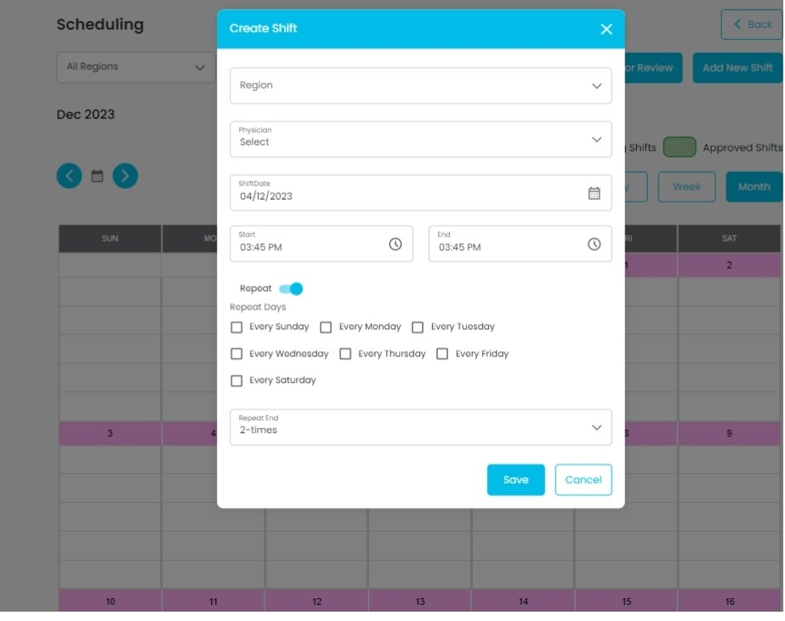

Fig37. Create Shift

**Description:**

This page will allow Admin to create shift for the provider with start date and time to end date and time. Admin can also create shifts that can be repeated in selected amount of time.

**Features:**

|  |  |  |  |
| --- | --- | --- | --- |
| **#** | **Feature** | **Type** | **Description** |
|  | Region | Dropdown | It will allow admin to select regions from region drop-down |
|  | Provider | Dropdown | It will allow admin to select provider based on selected regions from region drop-down |
|  | Day | Date picker | It will help to select the date of a shift |
|  | Start | Time Picker | It will help to select the start time of a shift |
|  | End | Time Picker | It will help to select the end time of a shift |
|  | Repeat | Toggle Button | It will allow us to repeat the shift. |
|  | Repeat days | Checkbox | It will be visible when you turn on the toggle button. You can select on which days you want to repeat the shift. |
|  | Repeat end | Dropdown | It will be visible when you turn on the toggle button. You can select how many times you want to repeat the shift. |
|  | Create | Button | Clicking on this button, the shift will be created with filled details |
|  | Cancel | Button | Clicking on this button, the popup will be closed without creating a shift. |

View Edit/Delete Shift:

When admin clicks on today’s shift or the future shift, View-shift popup will open to delete or edit that shift.

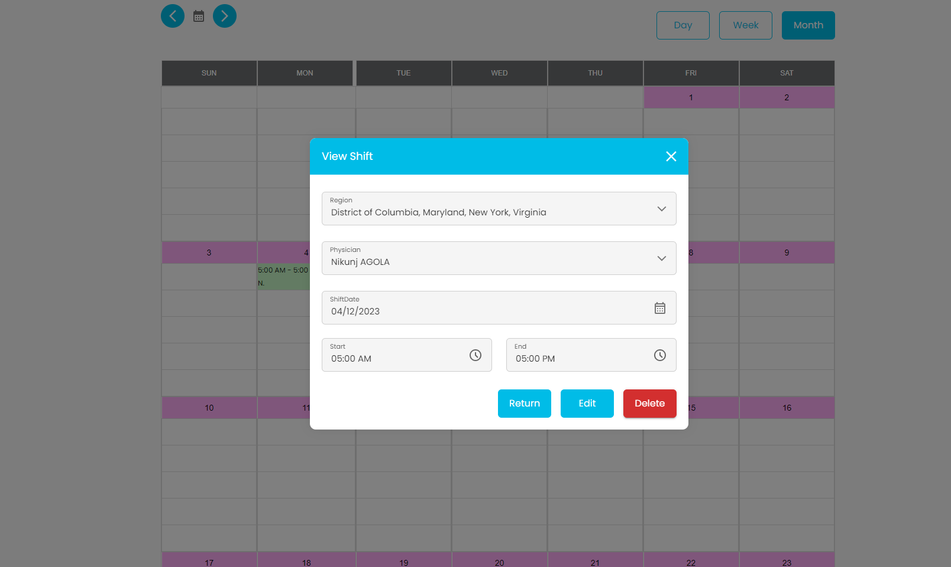

Fig38. View /edit /Delete Shift

**Features:**

|  |  |  |  |
| --- | --- | --- | --- |
| **#** | **Feature** | **Type** | **Description** |
|  | Region | Dropdown | It will show the shift’s region. It will be disabled |
|  | Provider | Dropdown | It will show the provider's name. It will be disabled |
|  | Day | Date picker | It will show the date of a shift. It will be disabled |
|  | Start | Time Picker | It will show the start time of a shift. It will be disabled |
|  | End | Time Picker | It will show the end time of a shift. It will be disabled |
|  | Return | Button | Clicking on this button will change the shift status from Pending to Approved and vice versa. |
|  | Edit | Button | Clicking on this button will make the date and start, end time fields enabled and Save button will be visible instead of Edit and admin can edit the details then click on save button to change the shift details. |
|  | Delete | Button | Clicking on this button will delete the created shift. |

Provider Location:

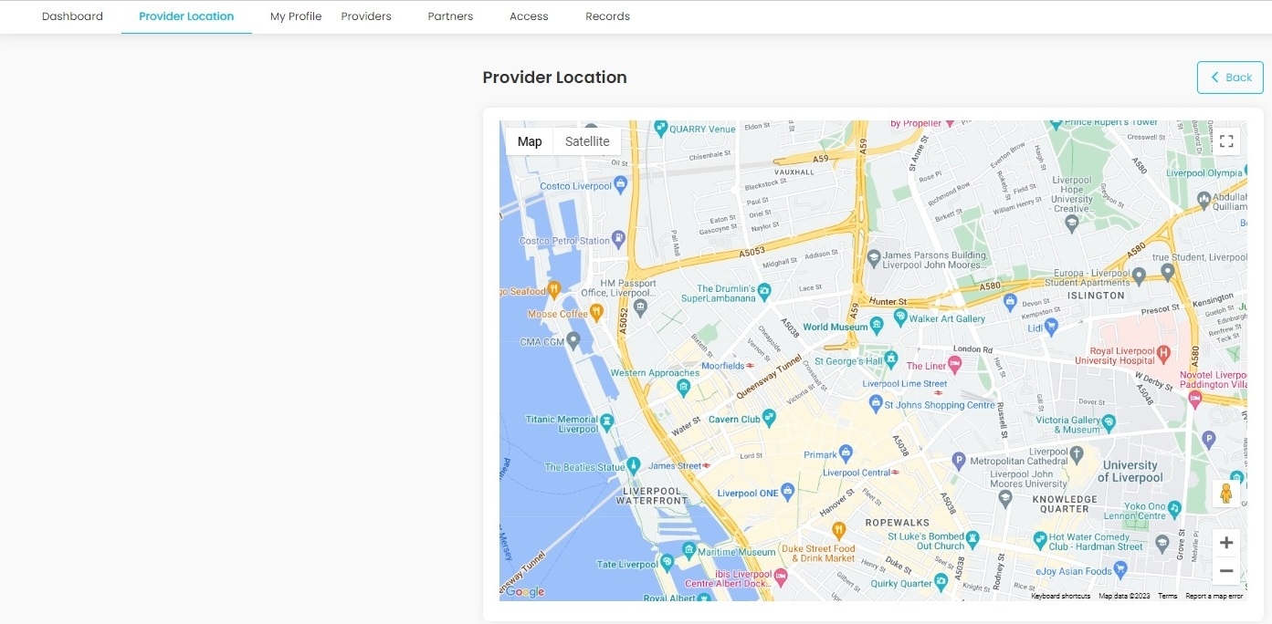

Fig39. Provider Location

**Description:**

This Page will show the Provider's (Physician) location in google map. Admins can see the exact location of every physician with their names.

Partners/ Vendors:

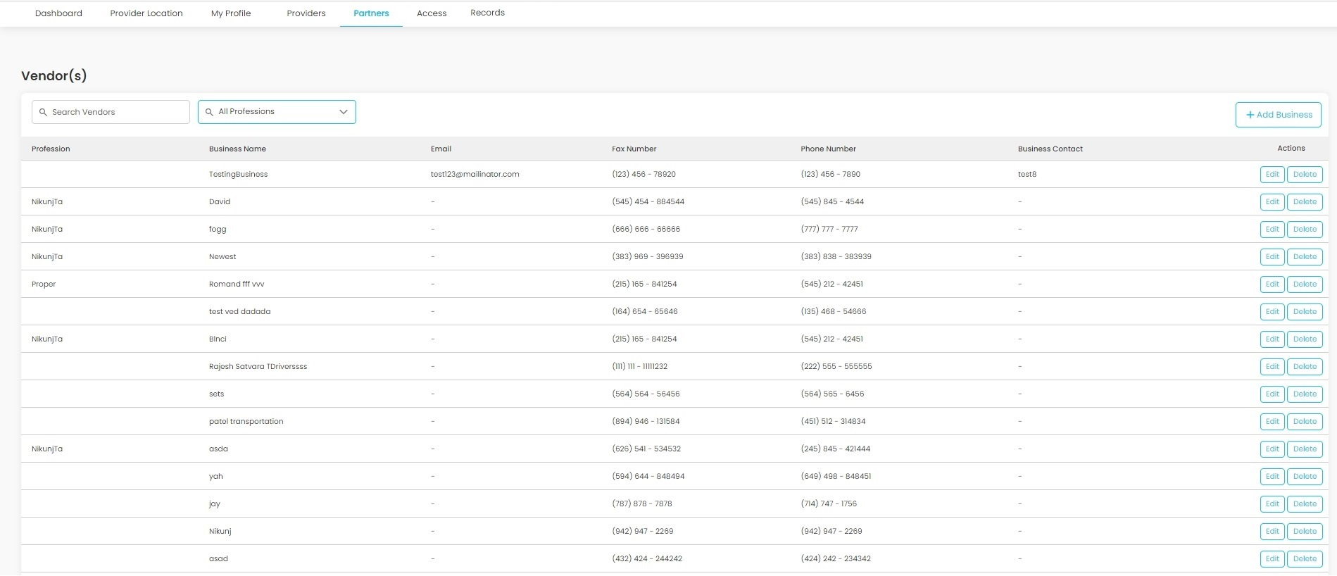

Fig40. Profession menu Partners/Vendors

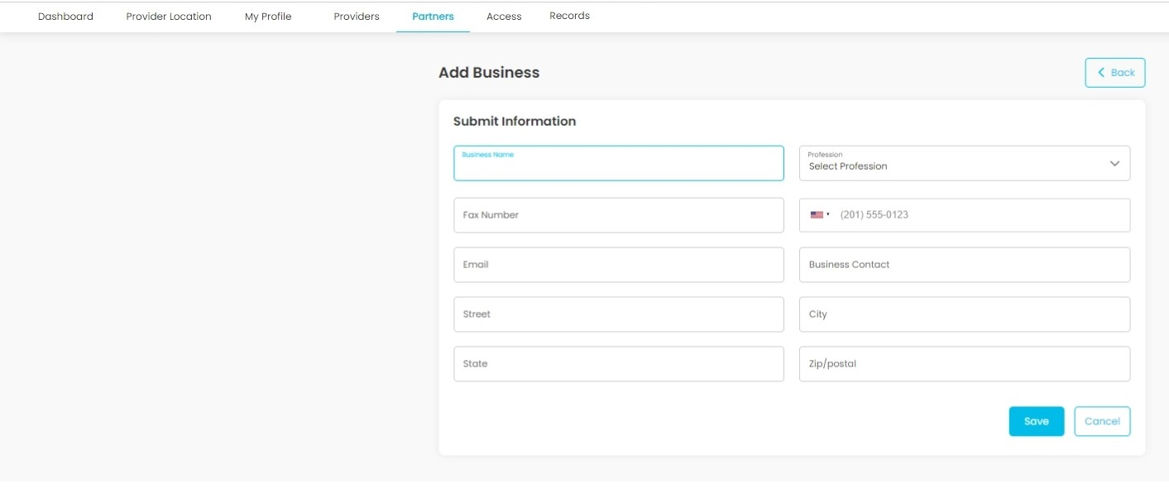  
Fig41.Add business page

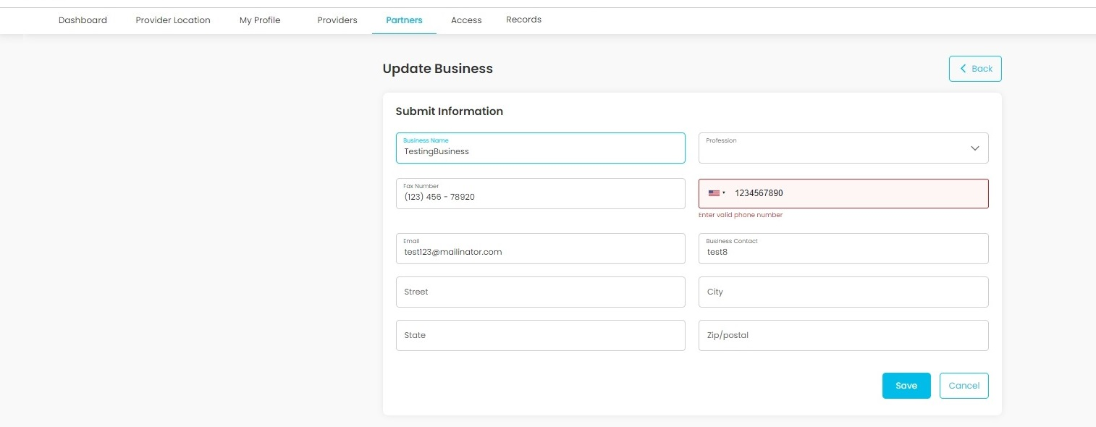  
Fig42.Edit business page

**Description:**

This page will show all the vendors available on the platform. Admin can Add, Edit or Delete any vendor.

**Features:**

|  |  |  |  |
| --- | --- | --- | --- |
| **#** | **Feature** | **Type** | **Description** |
|  | Add business | Button | Clicking on this button will redirect admin to add business(vendor) page. |
|  | Edit | Button | Clicking on this button will redirect admin to edit business page for particular vendor. |
|  | Delete | Button | Clicking on this button, Admin can delete any vendor. |

Add/Edit Vendor:

**Description:**

Admin can add or edit vendor using this page.

**Features:**

|  |  |  |  |
| --- | --- | --- | --- |
| **#** | **Feature** | **Type** | **Description** |
|  | Business name | Textbox | This will show Business name (Vendor name) |
|  | Profession | Dropdown | This will show Vendor’s profession. |
|  | Fax Number | Textbox | This will show Vendor’s fax number |
|  | Phone number | Textbox | This will show vendor’s phone number |
|  | Email | Textbox | This will show Vendors Email address |
|  | Business | Textbox | This will show Vendors Business Contact |
|  | Street | Textbox | This will show Vendor’s Street |
|  | City | Textbox | This will show Vendor’s city. |
|  | State | Textbox | This will show the Vendor’s state. |
|  | Zip/postal | Textbox | This will show the Vendor’s zip code. |
|  | Save | Button | Clicking on this button, admin can save new vendor or edit existing vendor |
|  | Cancel | Button | Clicking on this button will redirect admin to vendor's page |
|  | Back | Button | Clicking on this button will redirect admin to vendor's page |

Records:  
Patient Record/Patient History

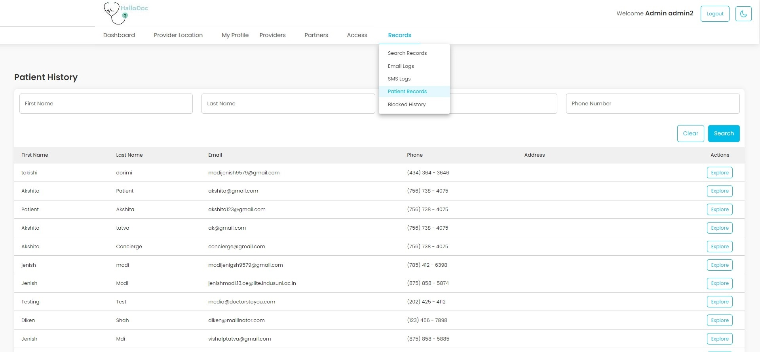

Fig43. Patient history

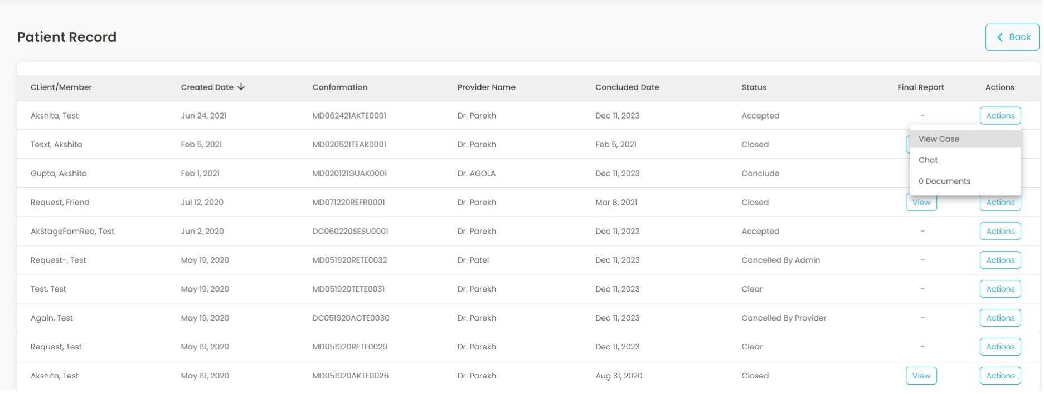

Fig44. Patient Record Explore

**Description:**

This page will show all patients' records. Admin can search patient by First name, last name, email and phone number.

**Features:**

|  |  |  |  |
| --- | --- | --- | --- |
| **#** | **Feature** | **Type** | **Description** |
|  | First name | Textbox | Admin can search Patients records by first name |
|  | last name | Textbox | Admin can search Patient records by last name |
|  | Email | Textbox | Admin can search patient records by email address. |
|  | Phone number | Textbox | Admin can search patient records by phone number. |
|  | Search | Button | Clicking on this button, Admin can apply all search filters on patient records. |
|  | Clear | Button | Clicking on this button will clear all search filters. |
|  | Explore | Button | Clicking on this button, Admin can explore specific patient's previous case history |
|  | View | Button | Clicking on this button, Medical-Report file for that patient will be download |
|  | Documents | Button | Clicking on this button, admin will redirect to View Uploads page. |

Search Records:

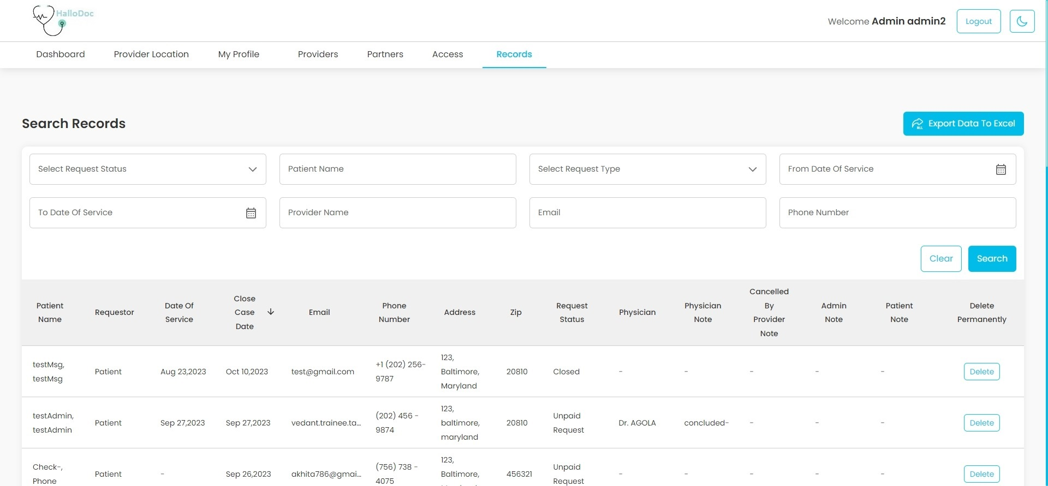

Fig45. Search Records

**Description:**

This page will show All Requests Data. Admin can search any request data by payment status, patient name, request type, date of service, email, phone number, provider name.

**Features:**

|  |  |  |  |
| --- | --- | --- | --- |
| **#** | **Feature** | **Type** | **Description** |
|  | Export Data to Excel | Button | Clicking on this button, Admin can export Request Data to excel file. |
|  | Select Request Status | Dropdown | Admin can search request data using payment status of the request. (Pending, Settled, Declined, Settled Offline) |
|  | Patient Name | Textbox | Admin can request data history using patient's name |
|  | Select Request Type | Dropdown | Admin can request data history using the request type of the request. |
|  | From Date of service | Date-picker | Admin can search request data to a from Date of Service. |
|  | To Date of service | Date-picker | Admin can search request data to a Date of Service. |
|  | Provider Name | Textbox | Admin can search request data by Provider name |
|  | Email | Textbox | Admin can search request data by email |
|  | Phone Number | Textbox | Admin can search request data by phone number |
|  | Clear | Button | Clicking on this button will clear all search values. |
|  | Search | Button | Clicking on this button, Admin can apply all search values on Requests Data. |
|  | Delete permanently | Button | Clicking on this button, Admin can delete a request data permanently. |

Logs (Email logs and SMS logs)

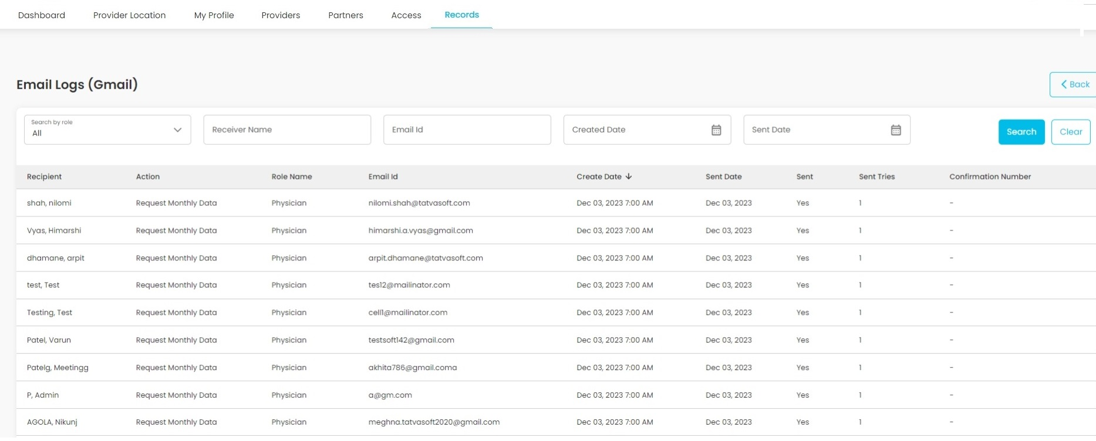

Fig45. Email Log

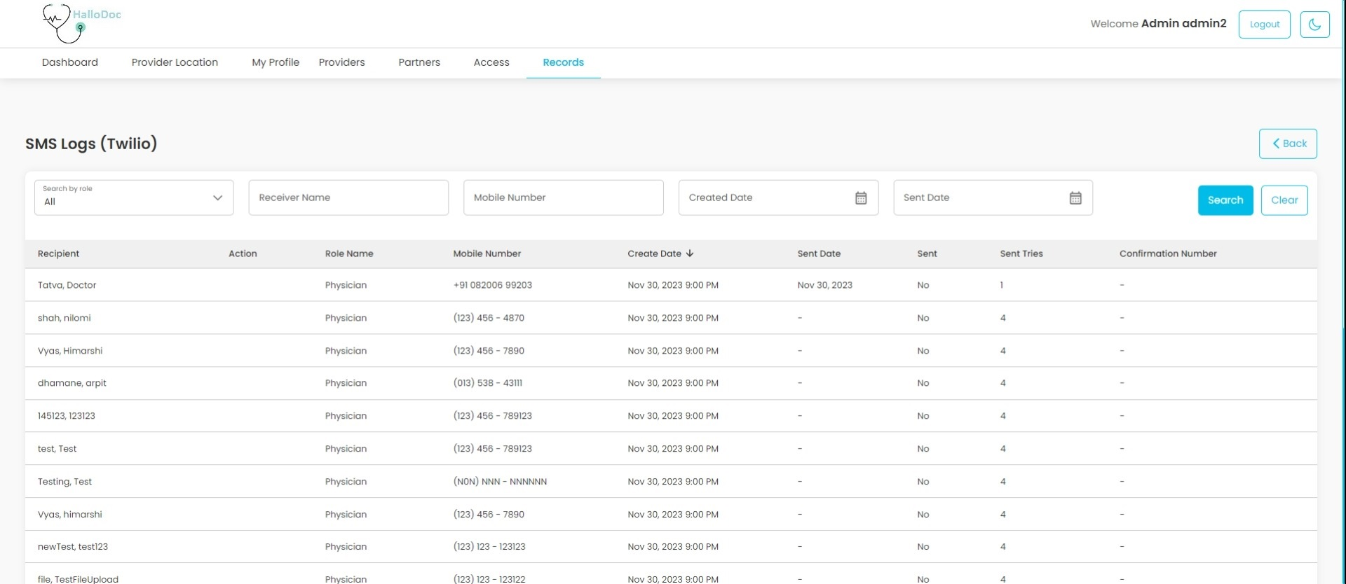

Fig46. SMS Log

**Description:**

This page will show all email and SMS logs.

**Features:**

|  |  |  |  |
| --- | --- | --- | --- |
| **#** | **Feature** | **Type** | **Description** |
|  | Search by Role | Dropdown | Admin can filter logs by selecting a role. By Default, Logs will be shown for all roles. |
|  | Recipient name | Textbox | Admin can search logs by Recipient name. |
|  | Email Id | Textbox | Admin can search email logs by email id. |
|  | Phone number | Textbox | Admin can search SMS logs by phone number. |
|  | Created Date | Date-picker | Admin can search logs by created date. |
|  | Sent Date | Date-picker | Admin can search logs by sent date. |
|  | Search | Button | Admin can search record as per filters |
|  | Clear | Button | Admin can clear search |

Cancel History(removed)

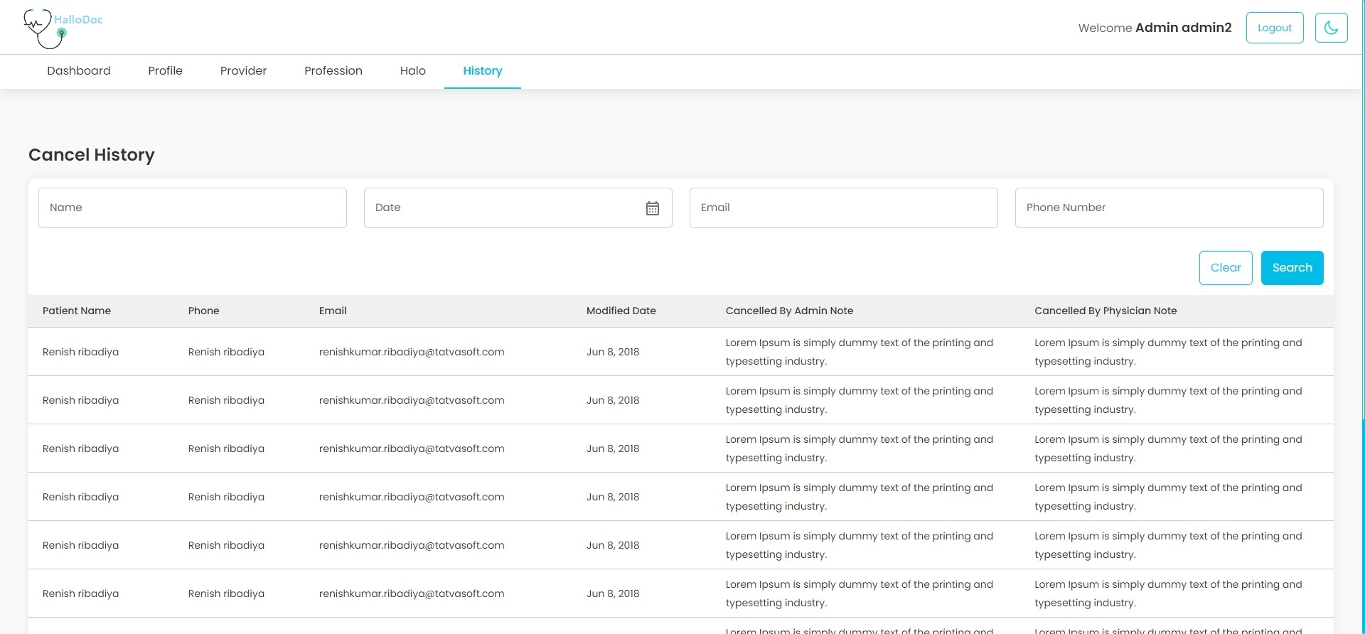

Fig. Cancel History

**Description:**

This page will show all cancelled cases. Admin can search cancelled cases by Name, Date, Email, Phone number.

**Features:**

|  |  |  |  |
| --- | --- | --- | --- |
| **#** | **Feature** | **Type** | **Description** |
|  | Name | Textbox | Admin can search cancelled case by patient name |
|  | Date | Date-picker | Admin can search cancelled case by date of Cancellation |
|  | Email | Textbox | Admin can search for cancelled case by email address. |
|  | Phone number | Textbox | Admin can search for cancelled case by phone number. |
|  | Search | Button | Clicking on this button, Admin can apply all search filter on cancelled case. |
|  | Clear | Button | Clicking on this button will clear all search filters. |

Block history:

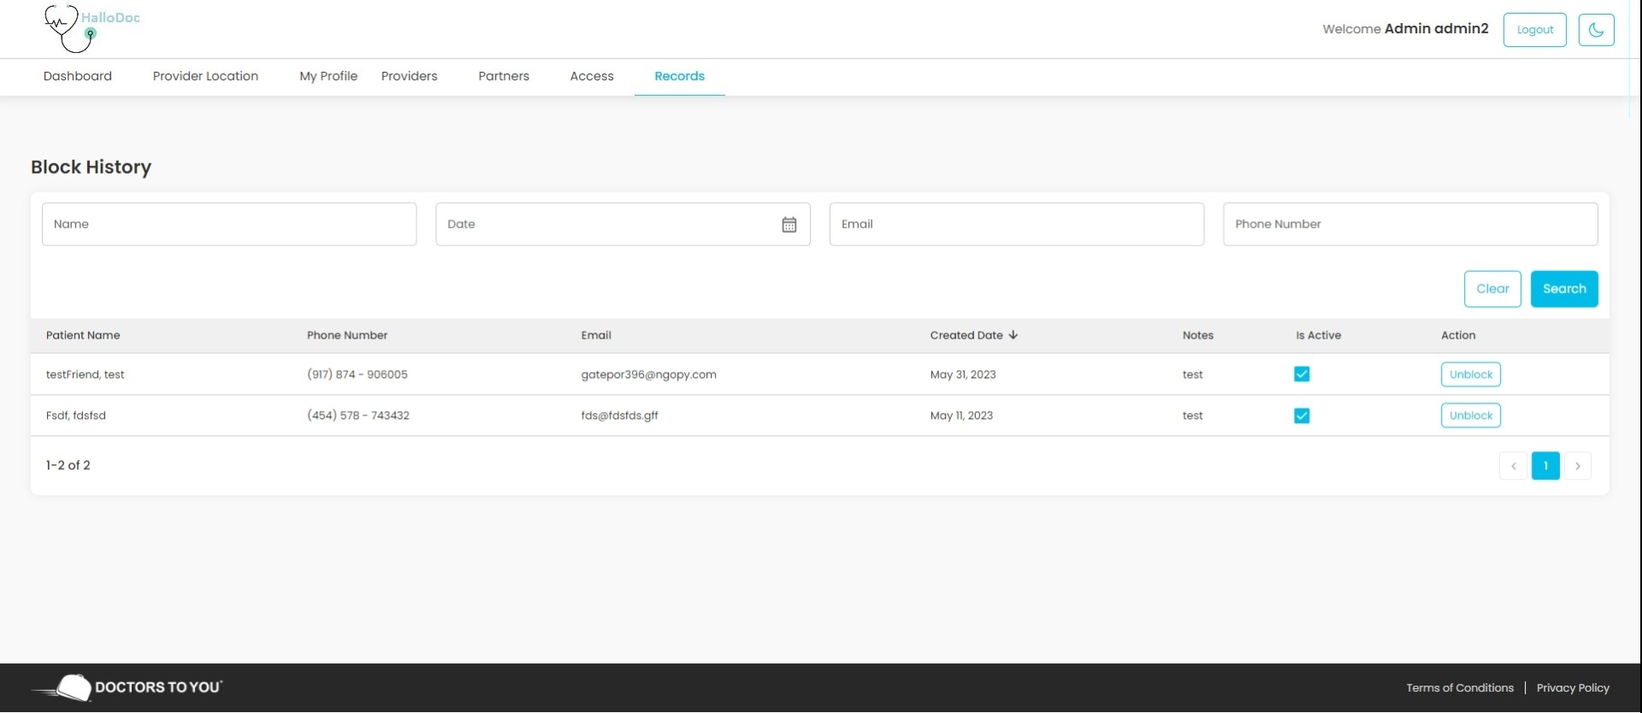

Fig47. Block History

**Description:**

This page will show all blocked cases. Admin can Search any blocked case by name, date, email and phone number.

**Features:**

|  |  |  |  |
| --- | --- | --- | --- |
| **#** | **Feature** | **Type** | **Description** |
|  | Name | Textbox | Admin can search blocked cases by patient name |
|  | Date | Date-picker | Admin can search blocked case by Created date |
|  | Email | Textbox | Admin can search blocked case by email address. |
|  | Phone number | Textbox | Admin can search blocked cases by phone number. |
|  | Search | Button | Clicking on this button, Admin can apply all search filter on blocked case. |
|  | Clear | Button | Clicking on this button will clear all search filters. |
|  | Unblock | Button | Clicking on this button, Admin can unblock any case |

Create Requests for Admin and physician:

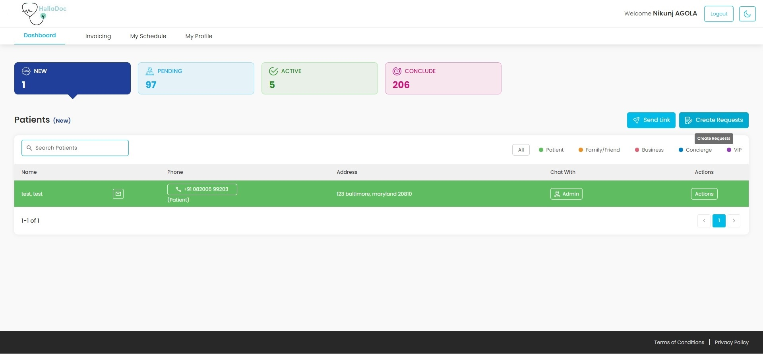

Fig48. Create Requests

**Description:**

This page will help for creating a request from admin and provider side.

**Features:**

|  |  |  |  |
| --- | --- | --- | --- |
| **#** | **Feature** | **Type** | **Description** |
|  | First Name | Textbox | It will show full name of the patient |
|  | Last Name | Textbox | It will show last name of the patient |
|  | Date of birth | Textbox | It will show date of birth of the patient |
|  | Phone number | Textbox | It will show Phone number of the patient |
|  | Email | Textbox | It will show Email of the patient |
|  | Street | Textbox | It will show Street of the user |
|  | City | Textbox | It will show City of the user |
|  | State | Textbox | It will show Street of the user |
|  | Zip code | Textbox | It will show Zip code of the user |
|  | Room | Textbox | It will show Room of the user |
|  | Verify | Button | Clicking on this button system will verify that the entered address belongs to their available service areas or not. |
|  | Map | Button | Clicking on this button will open the entered location in Google map |
|  | Physician notes | Textbox | It will be visible only when the provider is creating a request. It helps to add additional comment for provider related to that request. |
|  | Admin Notes | Textbox | It will be visible only when admin is creating a request. It helps to add additional comment for admin related to that request. |
|  | Save | Button | Clicking on this button will save a new request |
|  | Cancel | Button | Clicking on this button will redirect to dashboard page |
|  | Back | Button | Clicking on this button will redirect to dashboard page |

**3. Provider dashboard:**

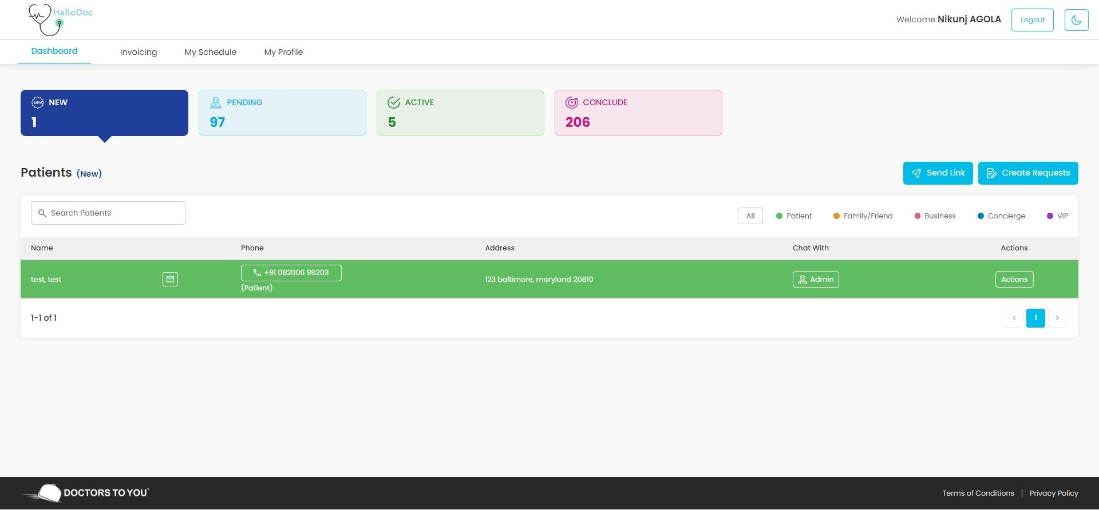

Fig49. Provider dashboard

**Description:**

Once the login is successfully completed by the provider, he/she will be automatically directed to the platform's landing page, which will showcase the patient requests. The provider will have the ability to filter the requests based on their request type and search for specific requests using the patient's name or the name of the requestor. On desktop devices, the requests can be viewed in a grid format, while on mobile devices, a card view will be provided for optimal display.

**Features:**

|  |  |  |  |
| --- | --- | --- | --- |
| **#** | **Feature** | **Type** | **Description** |
|  | New | Button | Clicking on this button, Provider can view all the newly created patient requests which are assigned to him by admin. |
|  | Pending | Button | Clicking on this button, Provider can view all patient requests which are accepted by that provider and patients who do not have accepted the agreement yet. |
|  | Active | Button | Clicking on this button, Provider can view all requests for which patients have accepted the agreement or providers has choose House-call for providing the care. |
|  | Conclude | Button | Clicking on this button, Provider can view all requests for which he has completed their service from his side. |
|  | Send Link | Button | Clicking on this button, Provider can send link to patients for creating a request via email and SMS. |
|  | Create Request | Button | Clicking on this button, Provider can create a request on behalf of patient. |
|  | Search Patients | Input | Provider can search patients by patient name, requestor name |

Provider Active State: Action >Encounter

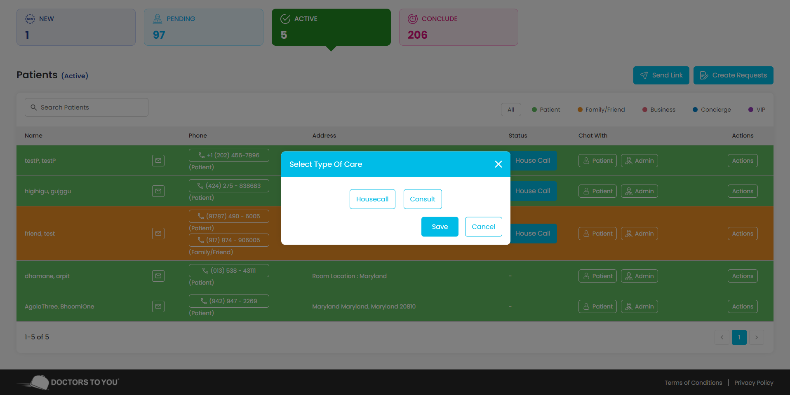

Fig50.Encounter (Type Of care)

When request is in Active state, provider needs to select the type of care for the patients. So, when request is in Active state and provider hasn’t selected any type of care then if he/she will click on Encounter from Actions menu then this kind of Select type of care pop-up will open with dropdown list which contains 2 options of care type: consult and house-call. If the provider selects the consult, then that request will move into Conclude state. If the provider will select house-call, then another dropdown will be visible to select the approximate arrival time of the provider to that patient’s house. That dropdown contains options from 0.5 hour to 6 hour with a 30-minute gap.

Provider Conclude State: Action > Encounter form

**Description:**

Once the call type is selected, the provider can add an encounter form which is basically a medical report created by checking patient’s medical condition. The provider can save the form multiple times, but he can finalize the form only one time. And after finalizing the form he cannot edit the form. Admin can see or edit the form whether form is finalized or not, but admin cannot finalize any encounter form.

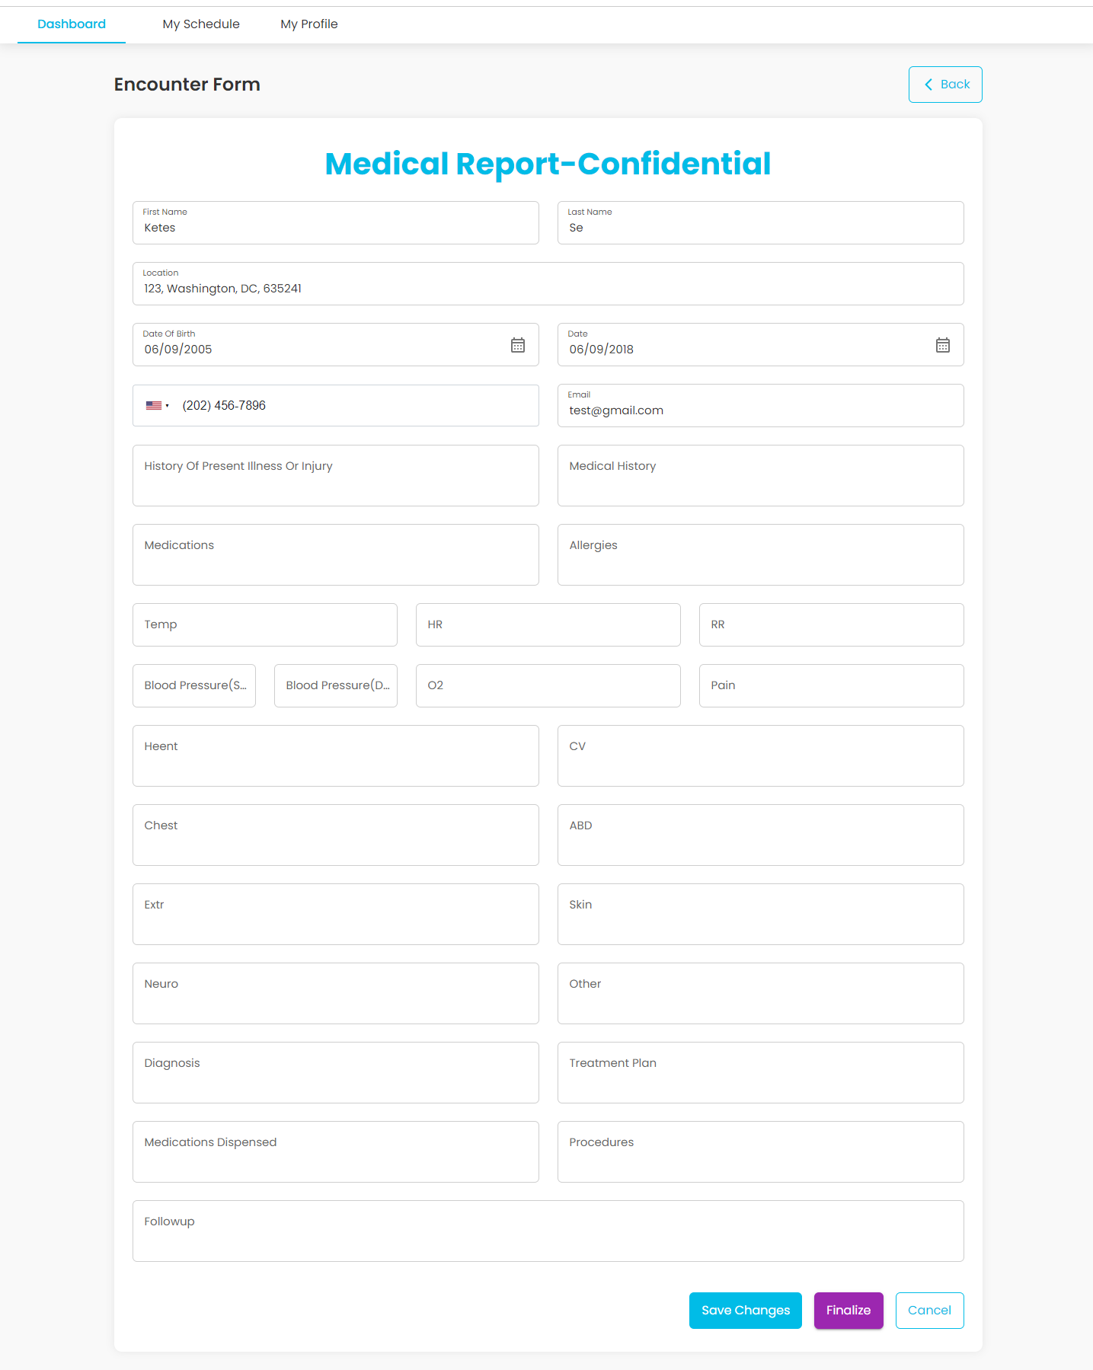

Fig51.Conclude State > Action > Encounter Form

**Features:**

|  |  |  |  |
| --- | --- | --- | --- |
| **#** | **Feature** | **Type** | **Description** |
|  | First name | Input | Users need to enter the patient's first name. |
|  | Last name | Input | Users need to enter patient last name. |
|  | Location | Input | Users need to enter the patient's whole address. |
|  | Date of Birth | Date-Picker | Users need to select the date of birth of the patient. |
|  | Date of Service | Date-picker | Users need to select the date of service of the request on which he provided service to the patient. |
|  | Phone Number | Input | Users need to enter the phone number of the patient. |
|  | Email | Input | Users need to enter the email of the patient. |
|  | History of Present Illness or Injury | Input | Users can enter the history of a patient’s illness or injury. |
|  | Medical History | Input | Users can enter a patient’s medical history. |
|  | Medications | Input | User can enter medications for the patient |
|  | Allergies | Input | Users need to enter allergies of the patient. |
|  | Temperature | Input | Users can enter the body temperature of the patient when the physician visits the patient. |
|  | HR (Heart Rate) | Input | User can enter patient’s heart rate |
|  | RR (Respiratory Rate) | Input | User can enter patient’s Respiratory Rate |
|  | Blood pressure | Input | User can enter patient’s blood pressure |
|  | O2 | Input | User can enter patient’s Oxygen level |
|  | Pain | Input | User can enter patient’s pain |
|  | HEENT | Input | Users can enter patient’s HEENT (head, eyes, ears, nose, and throat) examination results. |
|  | CV | Input | Users can enter a patient’s cardiovascular readings. |
|  | Chest | Input | Users can enter patient’s chest examination results. |
|  | ABD | Input | Users can enter a patient’s Abdomen (ABD) examination results. |
|  | Extr | Input | User can enter patient’s Extremities examination results. |
|  | Skin | Input | Users can enter patient’s skin examination results. |
|  | Neuro | Input | Users can enter patient’s neuro examination results. |
|  | Other | Input | Users can enter patient’s other examination results. |
|  | Diagnosis | Input | User can enter diagnosis of patient’s disease. |
|  | Treatment plan | Input | Users need to enter a treatment plan for the patient. |
|  | Medication dispensed | Input | Users need to enter medications which were dispensed during patient visits. |
|  | Procedures | Input | Users need to enter procedures from which patients must pass through. |
|  | Follow-up | Input | Users need to enter follow-up which should be taken by the patient. |
|  | Save Changes | Button | Clicking on this button will save encounter form and user will stay on same page. |
|  | Finalize | Button | Clicking on this button will finalize the encounter form and the user will be redirected to dashboard. |
|  | Cancel | Button | Clicking on this button, the user will be redirected to dashboard without saving any form data. |
|  | Back | Button | Clicking on this button, the user will be redirected to dashboard without saving any form data. |

Once the encounter form is finalized, the provider cannot open it to edit the form. If provider clicks on encounter button from action menu Encounter form Already finalized pop-up will be shown. From this pop-up provider you can download finalized encounter form.

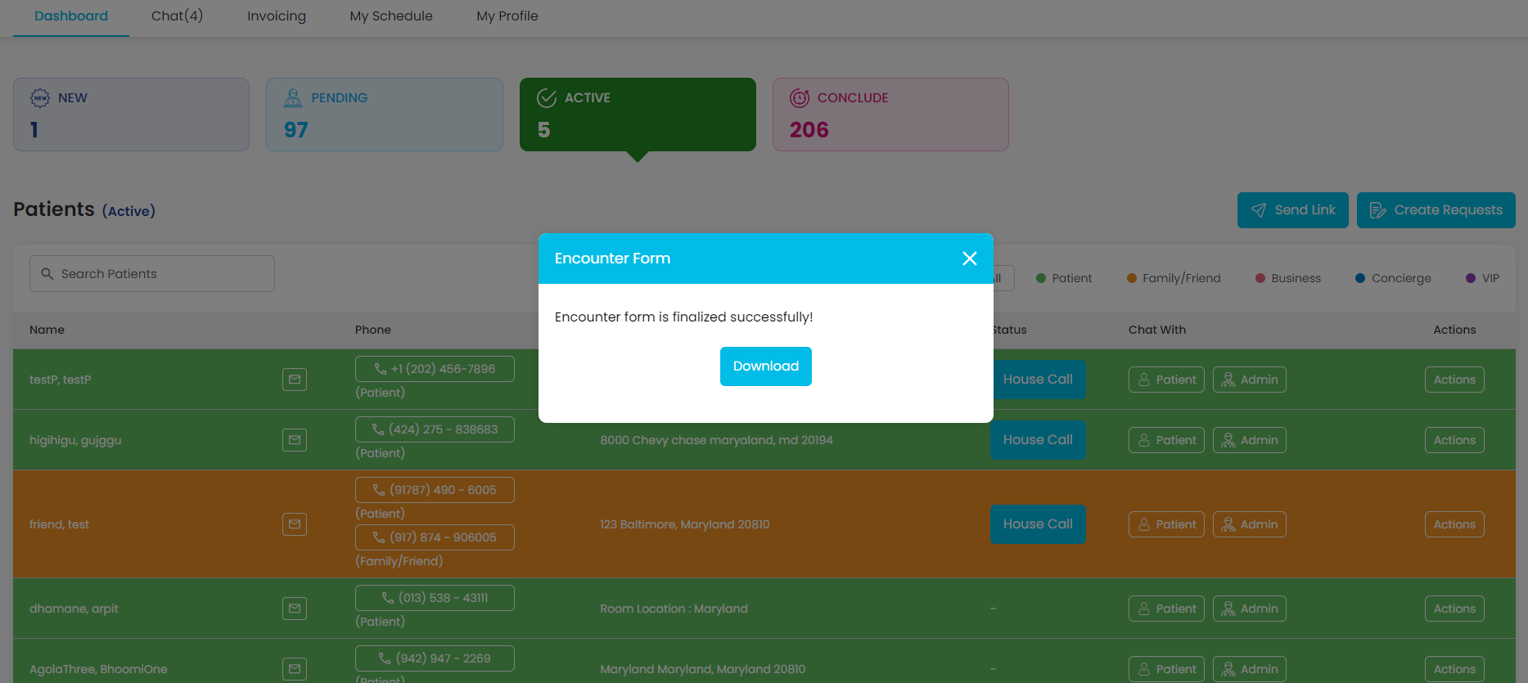

Fig52. Encounter Finalize popup

Provider > Pending State > Action > transfer request pop-up

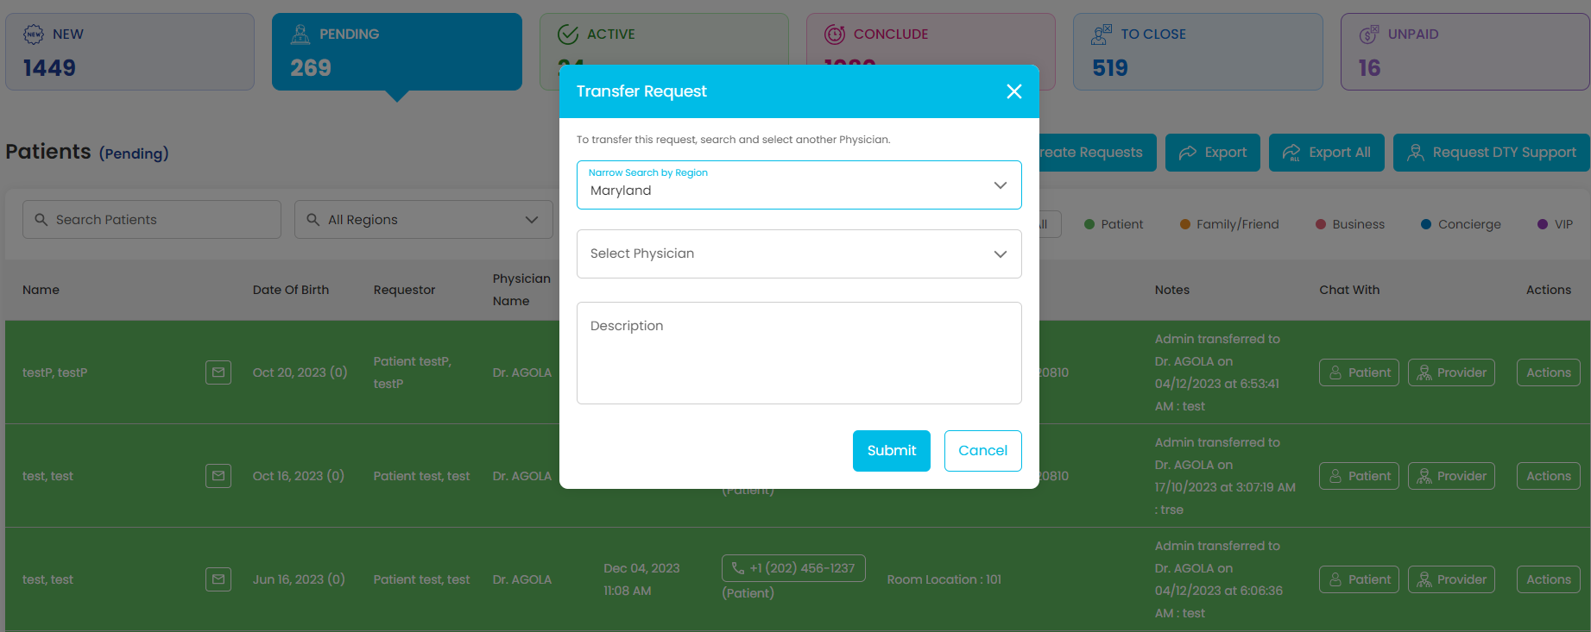

Fig53. Provider transfer request pop-up

**Description:**

This pop-up will allow Provider to transfer the request back to Admin. Then Admin will decide to whether to cancel the request or assign it to different or same provider.

**Features:**

|  |  |  |  |
| --- | --- | --- | --- |
| **#** | **Feature** | **Type** | **Description** |
|  | Description | Textbox | Detailed description for transferring the request to Admin |
|  | Submit | Button | Clicking on this button, the request will be transferred to the admin. Admin will get notification for the same and also able to view the transfer notes in View Notes page. |
|  | Cancel | Button | Clicking on this button, popup will be closed without transferring request to Admin. |

My profile:  
Provider My profile

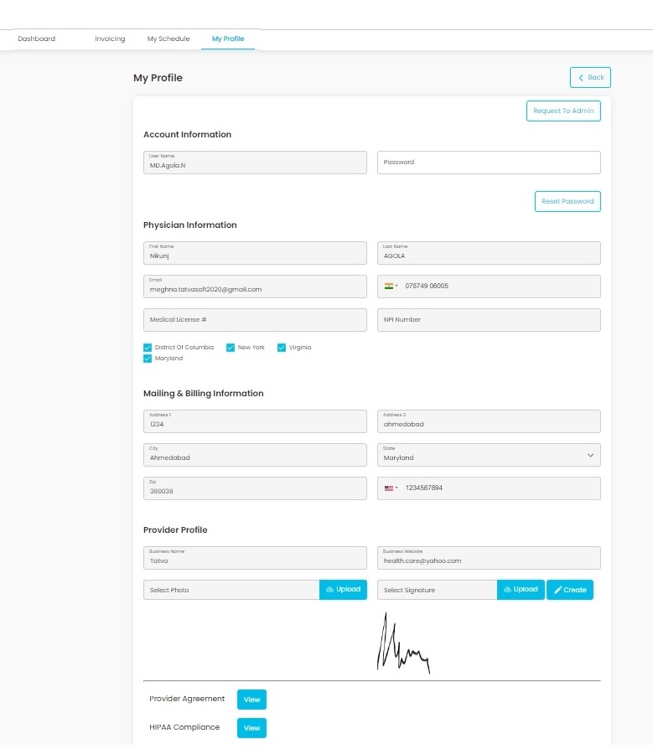

Fig54. Provider My Profile

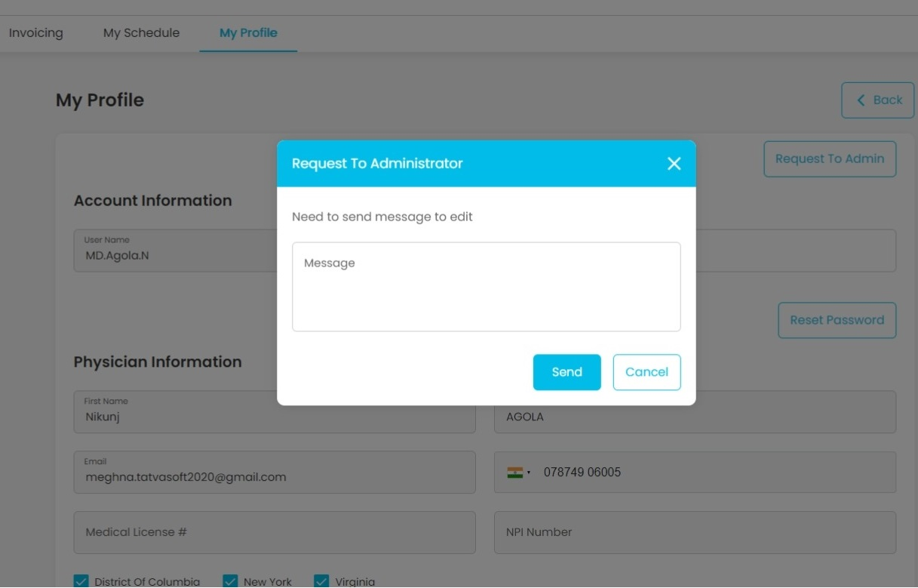

Fig55. Provider My Profile Request to Admin

**Description:**

This page will show the profile for the logged in provider. Providers can edit their information from this page. For the provider's My Profile page, if the provider wants to edit his/her profile, he/she has to request an admin first. Once the request is approved by the admin, the admin can then edit the details in the provider's profile using the provider page.

**Features:**

|  |  |  |  |
| --- | --- | --- | --- |
| **#** | **Feature** | **Type** | **Description** |
|  | Username | Textbox | This will show Username of the logged in user |
|  | Password | Textbox | User can reset their password using this field |
|  | Status | Dropdown | This will show Status of user (Pending, Active, not active) |
|  | Role | Dropdown | This will show role of the user |
|  | Edit | Button | Clicking on this button will enable password field and reset password button. and it will show Save and Cancel button instead of Edit button |
|  | Reset Password | Button | Clicking on this button will allow user to reset their password which was entered in Password field |
|  | First Name | Textbox | This will show first-name of the user |
|  | Last Name | Textbox | This will show last name of the user |
|  | Email | Textbox | This will show email of the user |
|  | Confirm Email | Textbox | This will be used to confirm the email |
|  | Mobile Number | Textbox | This will show mobile number of the user |
|  | Region | Checkbox | This will show all selected regions |
|  | Edit | Button | Clicking on this button will enable all fields for editing and also display Save and Cancel button instead of Edit |
|  | Save | Button | Clicking on this button will save all edited information beside the password |
|  | Cancel | Button | Clicking on this button will disable all fields without saving any changes. |
|  | Address 1 | Textbox | It will show first line of Address |
|  | Address 2 | Textbox | It will show second line of Address |
|  | City | Textbox | It will show City of the user |
|  | State | Textbox | It will show State of the user |
|  | Zip | Textbox | It will show Zip code associated with user address |
|  | Alternative Phone | Textbox | It will show alternative phone number of user |
|  | Edit | Button | Clicking on this button will enable all fields for editing and also display Save and Cancel button instead of Edit |
|  | Save | Button | Clicking on this button will save all edited information beside the password |
|  | Cancel | Button | Clicking on this button will disable all fields without saving any changes. |
|  | Back | Button | Clicking on this button will redirect to dashboard page. |
|  | Request To Admin | Button | Clicking on this button, request to administrator pop-up will open |
|  | Send | Button | Clicking on this button, admin will get notification via email. |

**4. Patient site:**

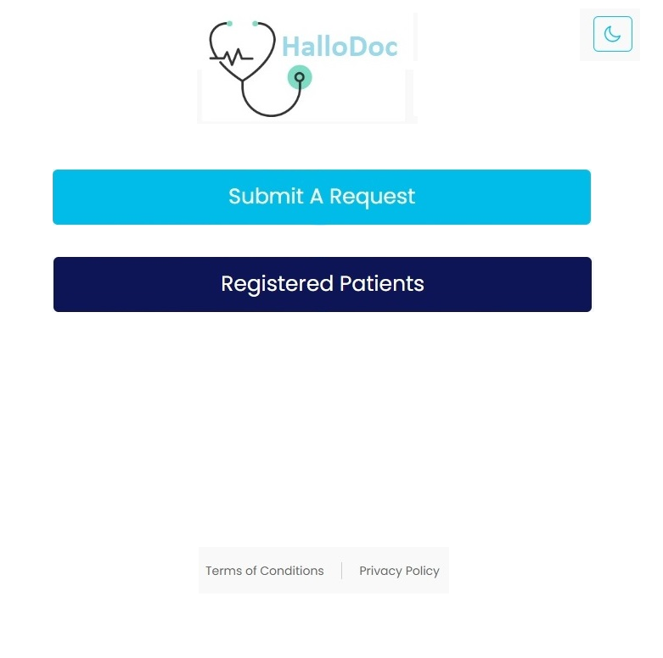p

Fig56. Patient site

**Description:**

This page will open when the patient hits the URL of our patient website.

**Features:**

|  |  |  |  |
| --- | --- | --- | --- |
| **#** | **Feature** | **Type** | **Description** |
|  | Submit Request | Button | Clicking on this button will redirect the patient to create request page |
|  | Registered Patients | Button | Clicking on this button will redirect the patient to login page |

Submit request screen:

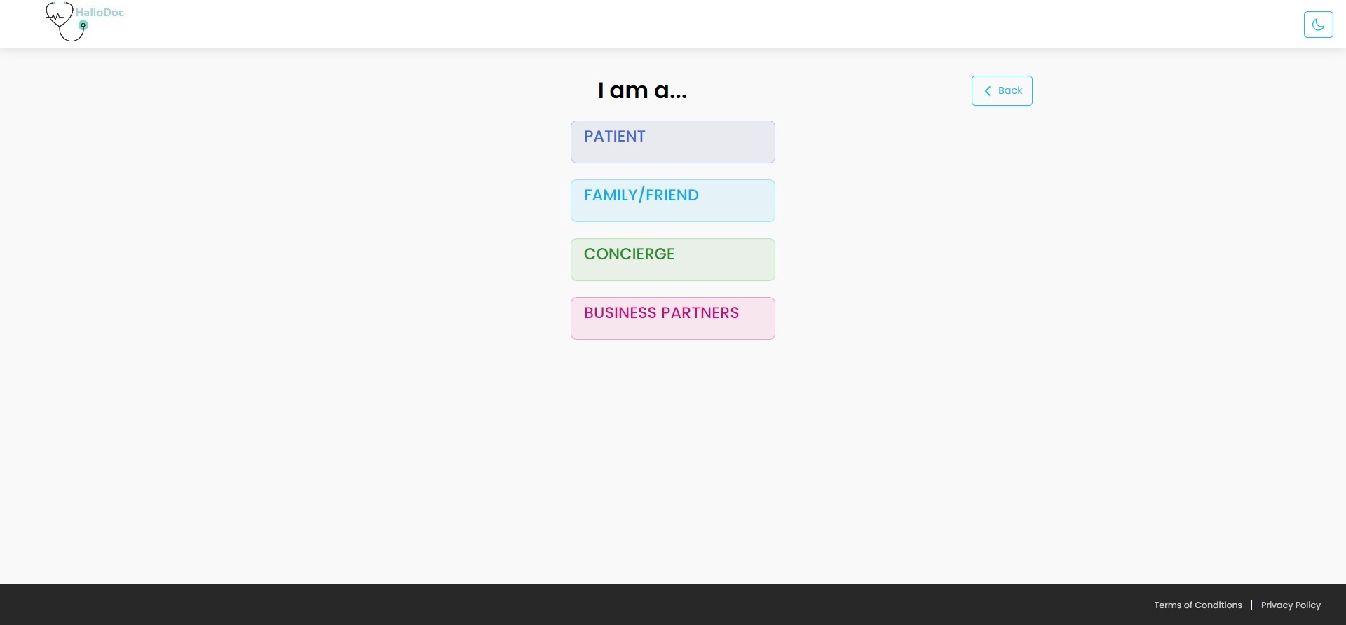

Fig57. Submit request screen

**Description:**

This page will allow patients to create 4 different types of requests.

**Features:**

|  |  |  |  |  |
| --- | --- | --- | --- | --- |
| **#** |  | **Feature** | **Type** | **Description** |
|  |  | Patient | Button | Clicking on this button will display the form of creating a request as a patient. |
|  |  | Family/Friend | Button | Clicking on this button will display the form of creating a request as a family/friend on behalf of a patient. |
|  |  | Concierge | Button | Clicking on this button will display the form of creating a request as a Concierge(hotel) on behalf of their guests who need the doctor consultation. |
|  |  | Business Partner | Button | Clicking on this button will display the form of creating a request as a business partner on behalf of their business partner who needs the doctor consultation. |

Create Patient request:

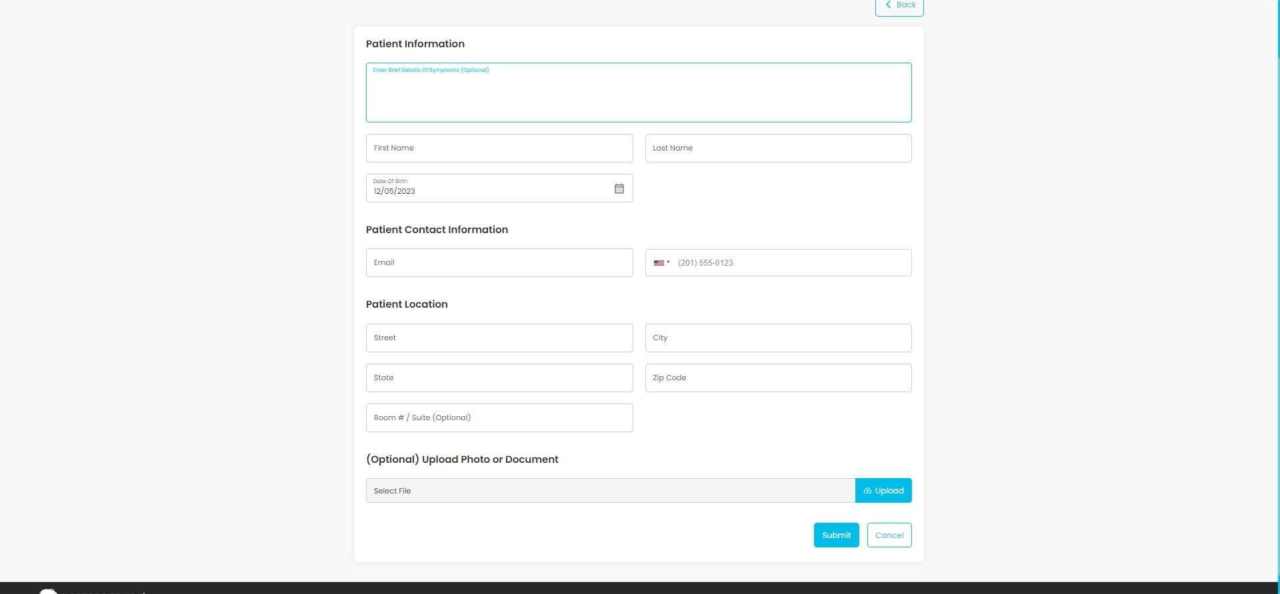

Fig58. Create Patient request

**Description:**

This page will allow any patient to add request for themself. Patients can add their symptoms, upload any files or documents which can help doctor for medical care.

**Features:**

|  |  |  |  |
| --- | --- | --- | --- |
| **#** | **Feature** | **Type** | **Description** |
|  | Symptoms | Textbox | Patients can enter their symptoms in this field. |
|  | First Name | Textbox | Patients need to enter their first name in this field. |
|  | Last Name | Textbox | Patients need to enter their last name in this field. |
|  | Birth Date | Input | Patients need to select their birthdate in this field. |
|  | Email | Textbox | Patients need to enter their email address in this field. |
|  | Phone Number | Textbox | Patients need to enter their phone number in this field. |
|  | Patient Location | Textbox | Patient must provide their location with zip code |
|  | Upload | Button | Clicking on this button, Patient can upload any image of document related to the request. |
|  | Submit | Button | Clicking on this button, Patient can submit their request. |
|  | Back | Button | Clicking on this button, Patient will be redirected to Submit Request screen. |

Create Family friend request:

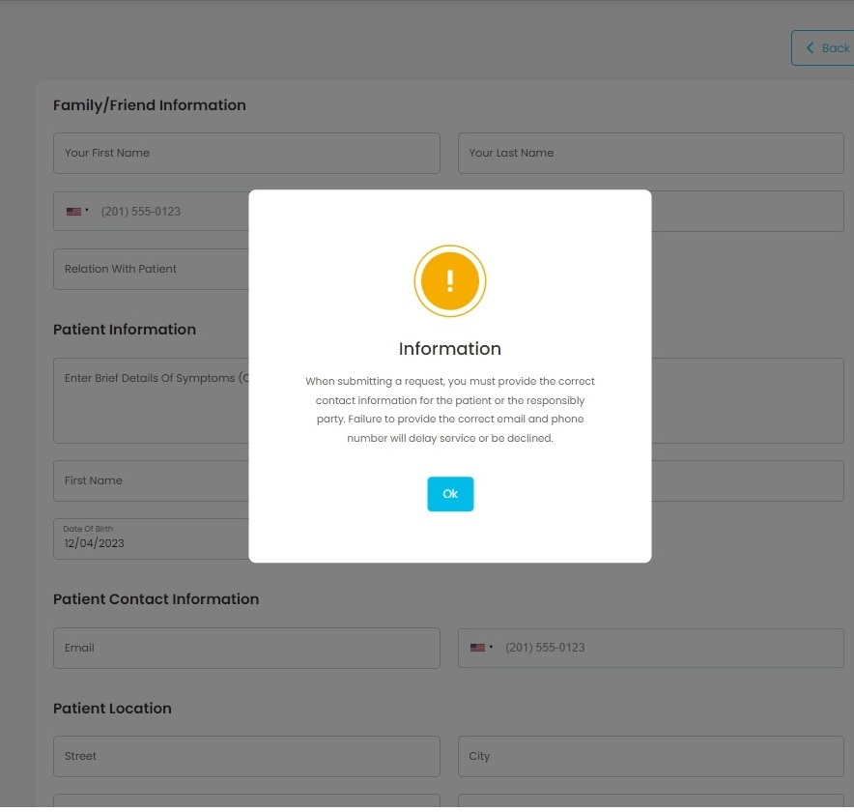  
  
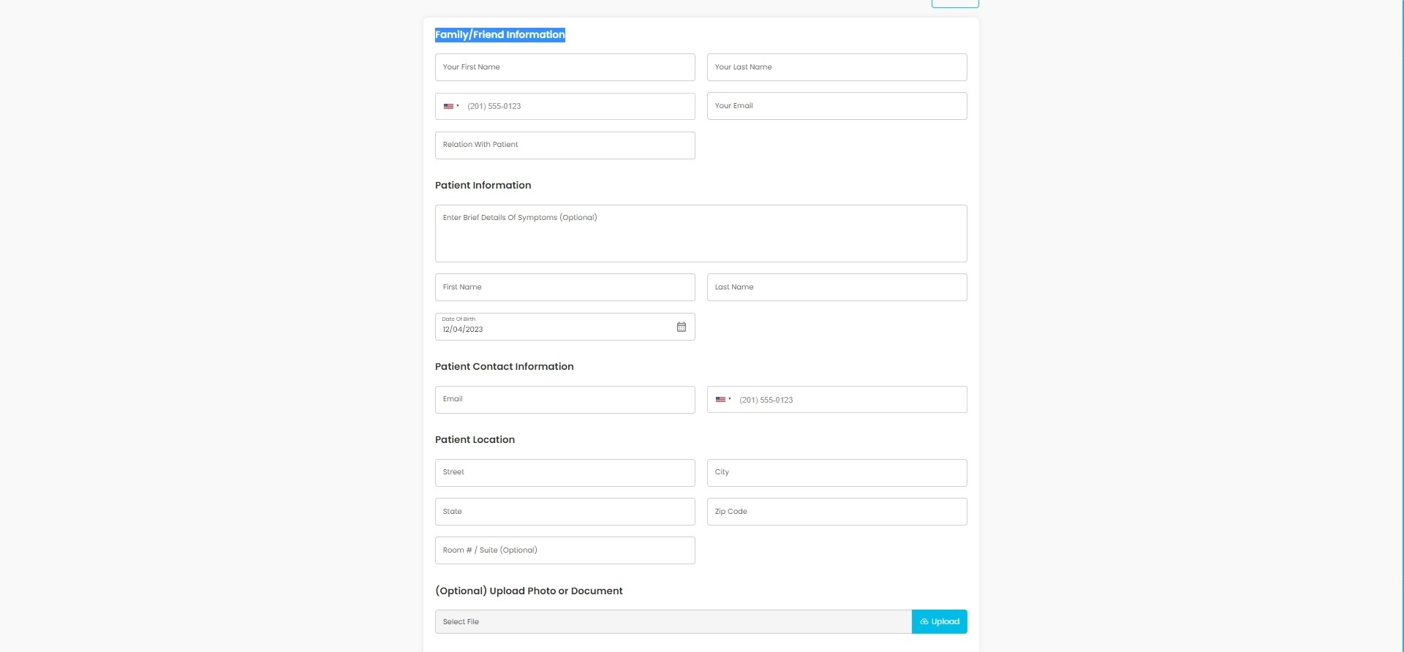

Fig59. Create Family/friend request

**Description:**

This page will allow any family member or friends to add requests on behalf of an actual patient.

**Features:**

|  |  |  |  |
| --- | --- | --- | --- |
| **#** | **Feature** | **Type** | **Description** |
|  | First name | Input | Requestors need to enter their first name in this field. |
|  | Last name | Input | Requestors need to enter their last name in this field. |
|  | Phone number | Input | Requestors need to enter their phone number in this field. |
|  | Email | Input | Requestors need to enter their email address in this field. |
|  | Relation with Patient | Input | Requestors can specify their relationship with the patient. |
|  | Symptoms | Input | Requestor can enter symptoms of patient. |
|  | Patient First name | Input | Requestor needs to enter the first name of the patient. |
|  | Patient last name | input | The requestor needs to enter the last name of the patient. |
|  | Patient Birthdate | Input | Requestor needs to select birthdate of patient. |
|  | Patient Email | Input | Requestor needs to enter patients email address |
|  | Patient Phone | Input | Requestor needs to enter patients phone number. |
|  | Patient Location | Input | Requestor needs to provide patients location with zip code. |
|  | Upload | Button | Clicking on this button, Requestor can upload any image of document related to the request. |
|  | Submit | Button | Clicking on this button, the Requestor can submit a request on behalf of the patient. |
|  | Back | Button | Clicking on this button, Requestor will be redirected to Submit Request screen. |

Create Concierge request:

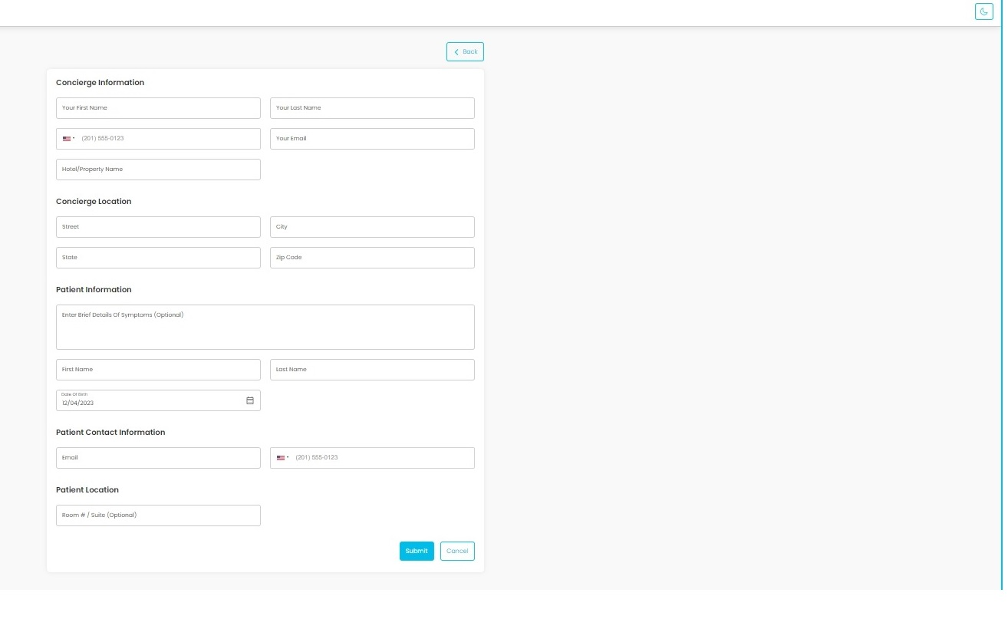

Fig60. Create concierge request

**Description:**

This page will allow any concierge (hotel staff) to create medical care request for a patient.

**Features:**

|  |  |  |  |
| --- | --- | --- | --- |
| **#** | **Feature** | **Type** | **Description** |
|  | First name | Input | Requestors need to enter their first name in this field. |
|  | Last name | Input | Requestors need to enter their last name in this field. |
|  | Phone number | Input | Requestors need to enter their phone number in this field. |
|  | Email | Input | Requestors need to enter their email address in this field. |
|  | Hotel/ Property name | Input | Requestors need to enter their property name in which patient needs medical care. |
|  | Concierge location | Input | Requestor needs to provide their location with zip code. |
|  | Symptoms | Input | Requestor can enter symptoms of patient. |
|  | Patient First name | Input | Requestor needs to enter the first name of the patient. |
|  | Patient last name | input | The requestor needs to enter the last name of the patient. |
|  | Patient Email | Input | Requestor needs to enter patients email address |
|  | Patient Phone | Input | Requestor needs to enter patients phone number. |
|  | Room number/ location | Input | Requestor can provide room number in which patient is stayed. |
|  | Submit | Button | Clicking on this button, the Requestor can submit a request on behalf of the patient. |
|  | Back | Button | Clicking on this button, Requestor will be redirected to Submit Request screen. |

Create business request:

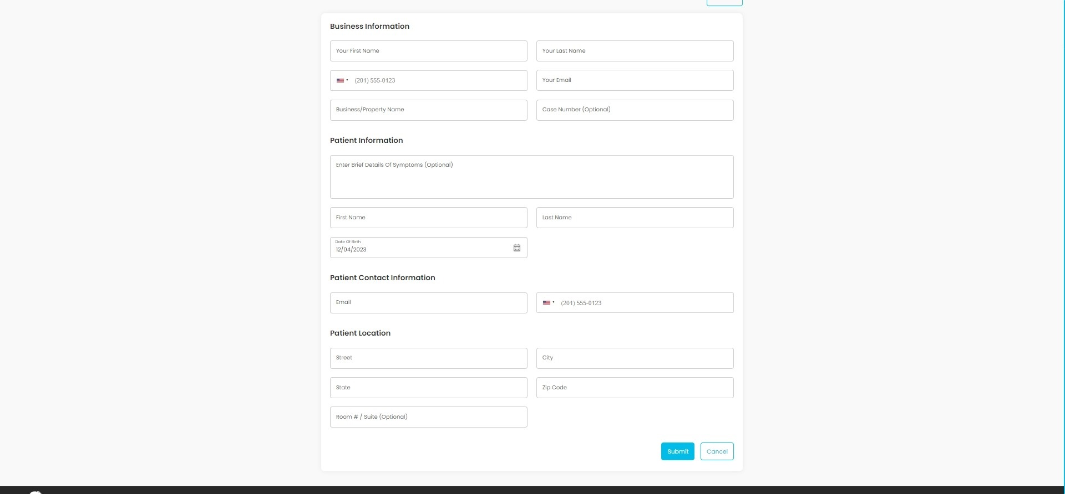

Fig61. Create business request

**Description:**

This page will allow any business partner to create medical requests for patients.

**Features:**

|  |  |  |  |
| --- | --- | --- | --- |
| **#** | **Feature** | **Type** | **Description** |
|  | First name | Input | Requestors need to enter their first name in this field. |
|  | Last name | Input | Requestors need to enter their last name in this field. |
|  | Phone number | Input | Requestors need to enter their phone number in this field. |
|  | Email | Input | Requestors need to enter their email address in this field. |
|  | Business/ Property name | Input | Requestors need to enter their business name |
|  | Case Number | Input | Requestor can enter case number of patient |
|  | Symptoms | Input | Requestor can enter symptoms of patient. |
|  | Patient First name | Input | Requestor needs to enter the first name of the patient. |
|  | Patient last name | input | The requestor needs to enter the last name of the patient. |
|  | Patient Email | Input | Requestor needs to enter patients email address |
|  | Patient Phone | Input | Requestor needs to enter patients phone number. |
|  | Patient Location | Input | Requestor needs to provide patients location with zip code. |
|  | Submit | Button | Clicking on this button, the Requestor can submit a request on behalf of the patient. |
|  | Back | Button | Clicking on this button, Requestor will be redirected to Submit Request screen. |

Registered Patient:

**Description:**

This page will appear when the user lands on the platform.

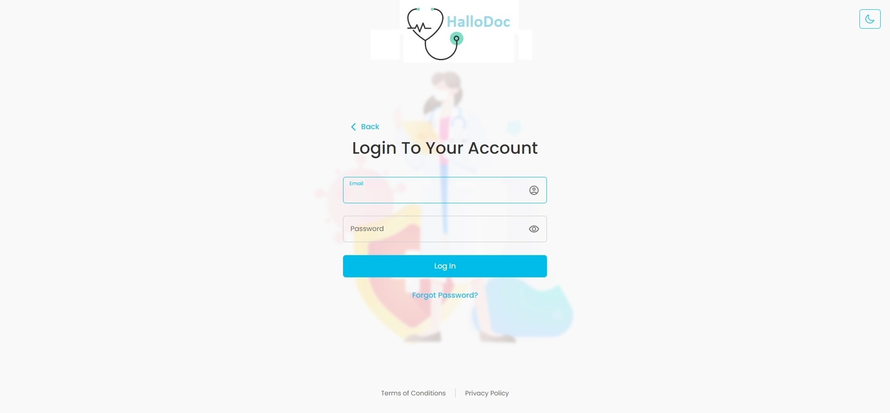

Fig62.Login Patient Account

**Description:**

Users can login to platform using their email address and password.

**Features:**

|  |  |  |  |
| --- | --- | --- | --- |
| **#** | **Feature** | **Type** | **Description** |
|  | Email address | Input | User will need to enter his email address in this text box. |
|  | Password | Input | Users will need to enter his password in this text box. |
|  | Login | Button | After entering the correct email address and password, clicking on this button will allow user to sign into the platform. |
|  | Forgot password | Link | If a user forgets his or her password, he or she must select “Forgot password?” |
|  | Footer links | Link | It will display links to pages such as Terms of condition and privacy policy. |

|  |  |
| --- | --- |
|  |  |

## Reset Password

**Description:**

Users will receive a link for this page via email when requested through forgot password page. When Page is loaded Link will be checked for expiration.

**Features:**

|  |  |  |  |
| --- | --- | --- | --- |
| **#** | **Feature** | **Type** | **Description** |
|  | Password | Input | Users will need to enter a new password. |
|  | Confirm Password | Input | User will need to confirm the new password |
|  | Reset | Button | Clicking on this button, User can reset their password. |

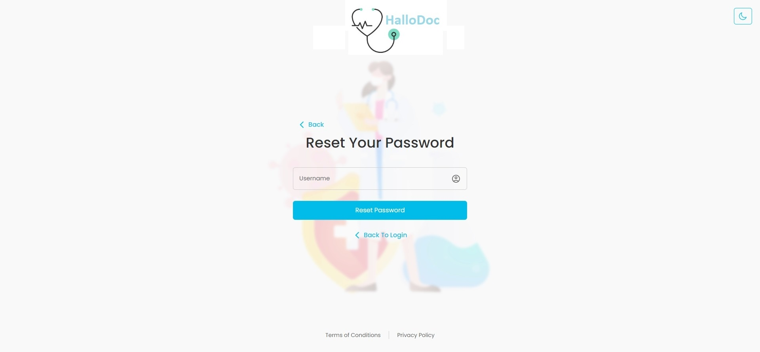

Fig63.Reser Your Password

Patient Dashboard:

**Description:**

This page will be shown when Patient logins to the platform with valid patient credentials. This page will allow patients to see their request status.

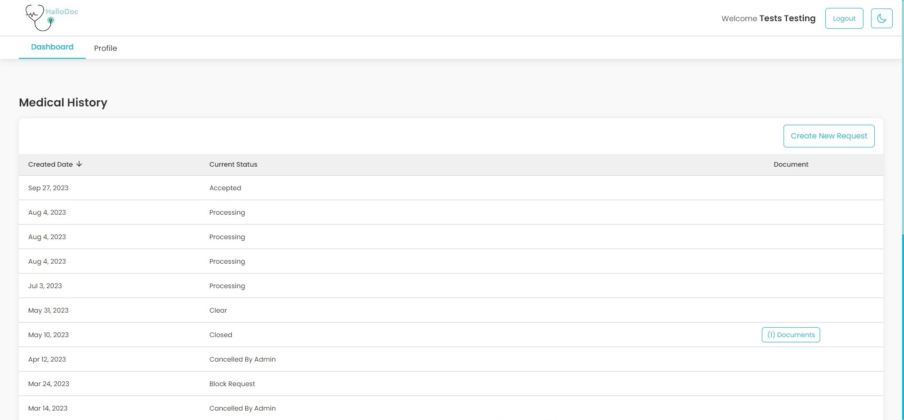

Fig64. Patient Dashboard

**Features:**

|  |  |  |  |
| --- | --- | --- | --- |
| **#** | **Feature** | **Type** | **Description** |
|  | Documents | Button | Clicking on this button will redirect Patient to View Documents page. |
|  | Create New Request | Button | Clicking on this button, Patient can create new request for themself or someone else. |

Create New Request

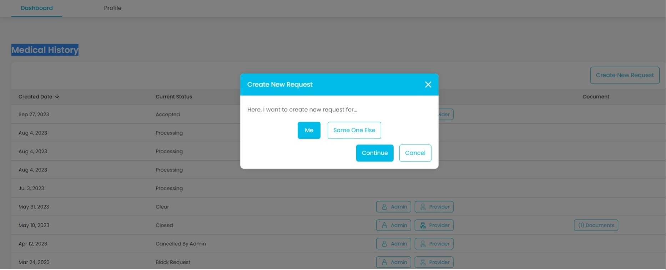

Fig65.Patient Create New Request

Submit Information me

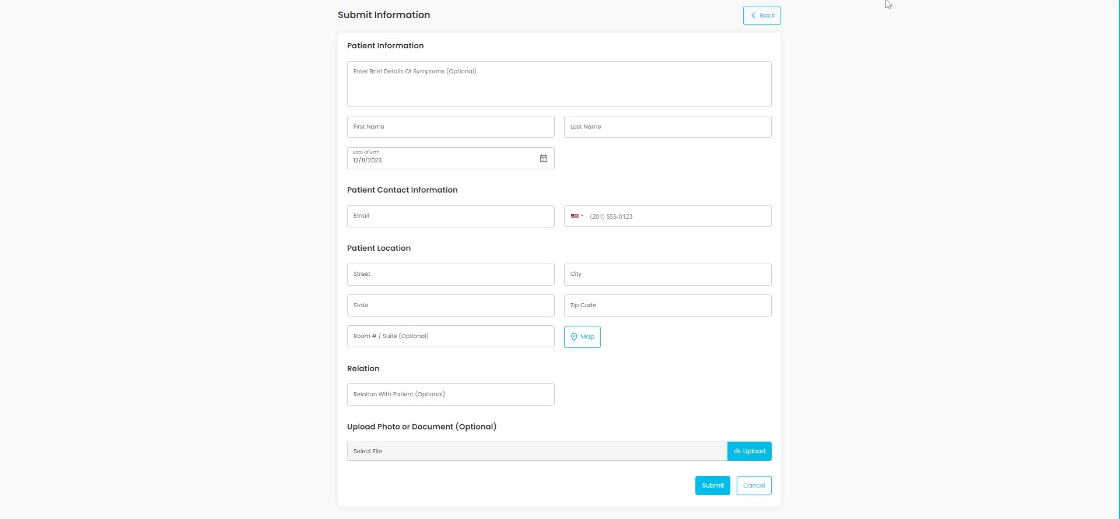

Fig66.Submit Information me

Submit Information Someone else

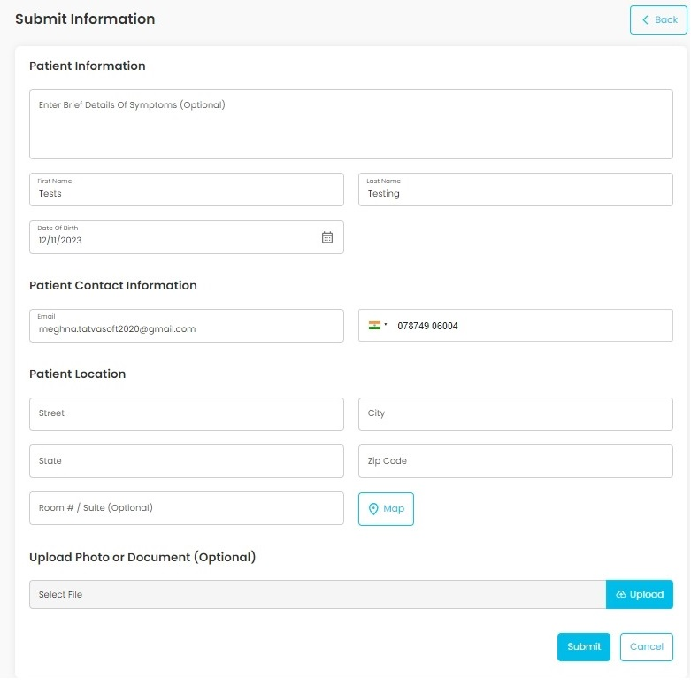

Fig67.Submit Information Someone else

View Documents:

**Description:**

This page will allow patients to download all the documents uploaded for request and also patients can upload new documents.

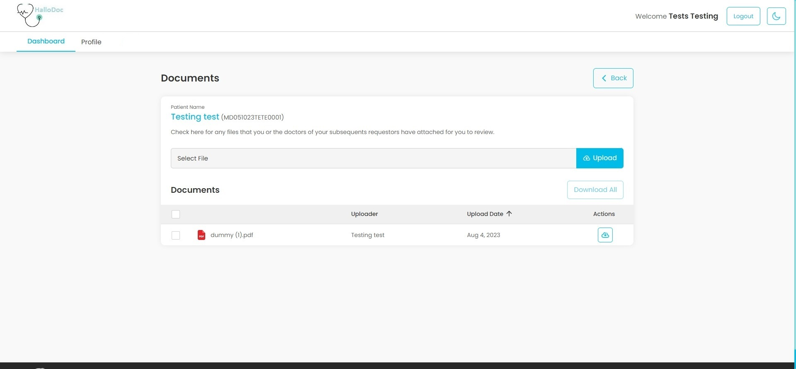

Fig68. View Documents

**Features:**

|  |  |  |  |
| --- | --- | --- | --- |
| **#** | **Feature** | **Type** | **Description** |
|  | Upload | File | Patients can upload any file using this file input. |
|  | Download | Button | Clicking on this button, Patient can download the document |

**Technology Stack**

Use relevant technologies as per instructions provided:

* Back end: ASP. Net Core API | Node JS | ASP. Net MVC | PHP 7
* Front end: React JS | Angular 11+ | Vue JS | ASP. Net MVC | PHP 7
* Database: SQL Server 2017 | Mongo | Postgres | My SQL
* Tools/IDE: Visual Studio 2019 | Visual Studio Code
* Source Control Repository: GitHub
* ORM: Entity Framework | Sequalize

**Thank you**